**Step-1**  
  
**Create VPC with CIDR Range- 192.168.0.0/16**

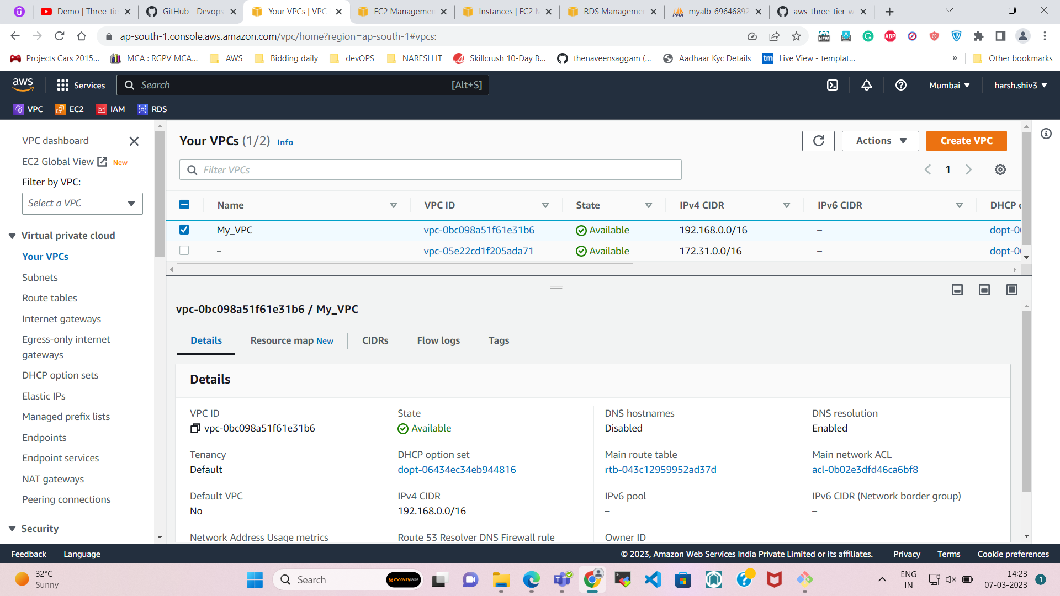

**Step-2**  
  
**Create Subnets with CIDR Range- 192.168.1.0/24 to 192.168.9.0/24**   
  
**1st 3 Subnets are for Public Web server 192.168.1.0/24, 192.168.2.0/24 & 192.168.3.0/24**  
**2nd 3 Subnets are for Private App server 192.168.4.0/24, 192.168.5.0/24 & 192.168.6.0/24**

**3rd 3 Subnets are for Private DB server 192.168.7.0/24, 192.168.8.0/24 & 192.168.9.0/24**

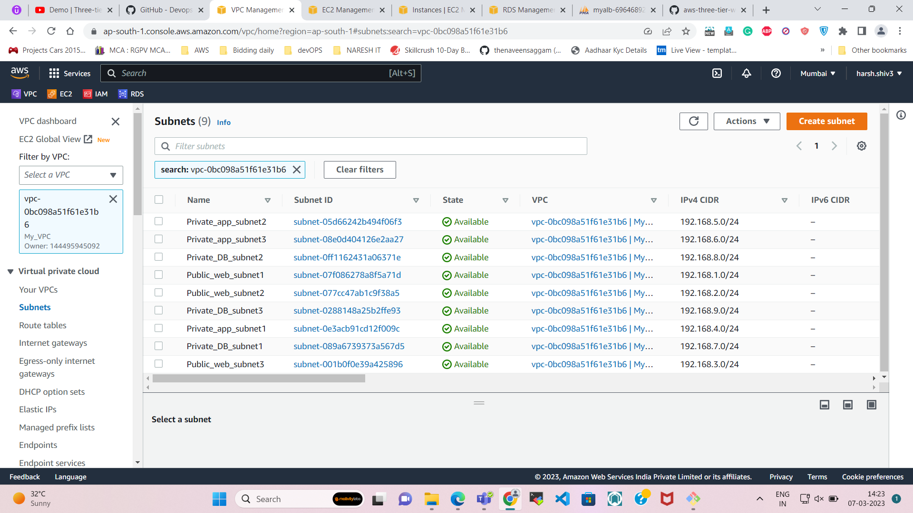

**Step-3**  
  
**Create 3 Route Table with our own VPC.**

**1st for Public Web Server**  
**2nd for Private App Server.**

**3rd for Private DB Server.**

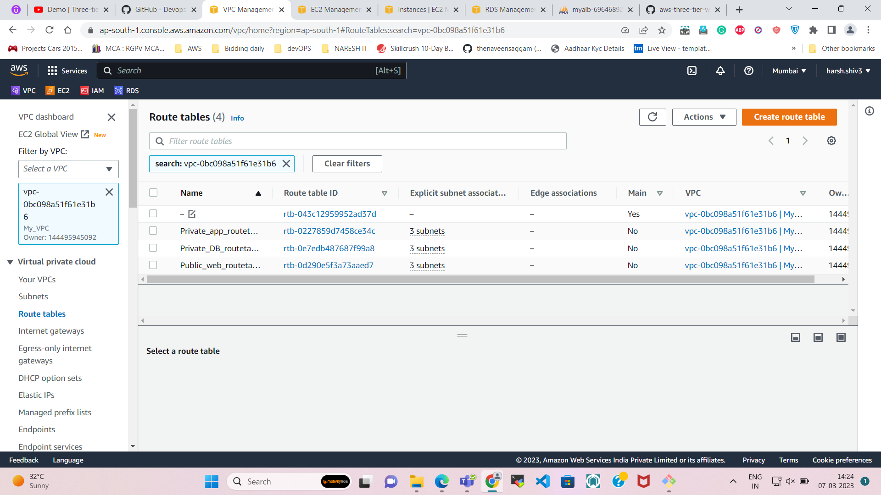

**Step-4**  
  
**Create IGW for our own VPC.**

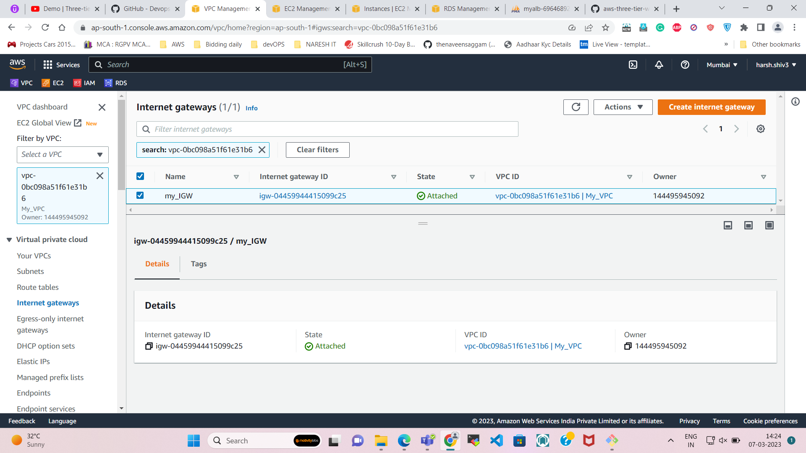

**Step-5**  
  
**Create NAT for our own VPC.**

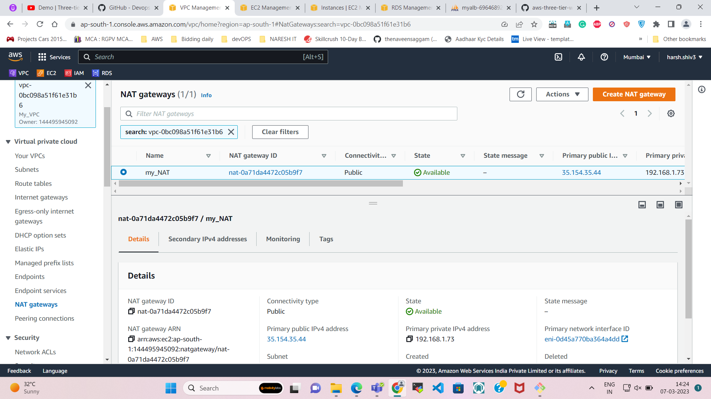

**Step-6**  
  
**Subnet Association-**  
  
**- Public web route with public web subnet.**

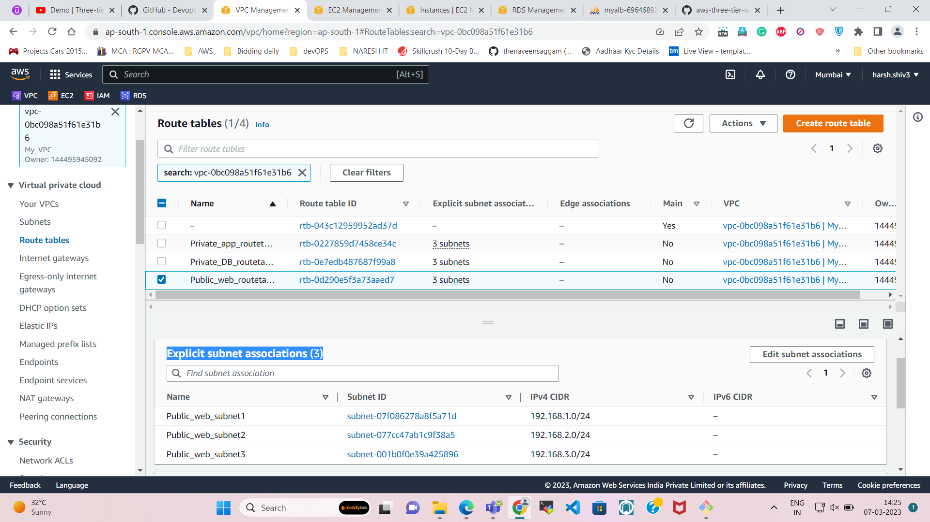

* **Private App route with Private App subnet.**

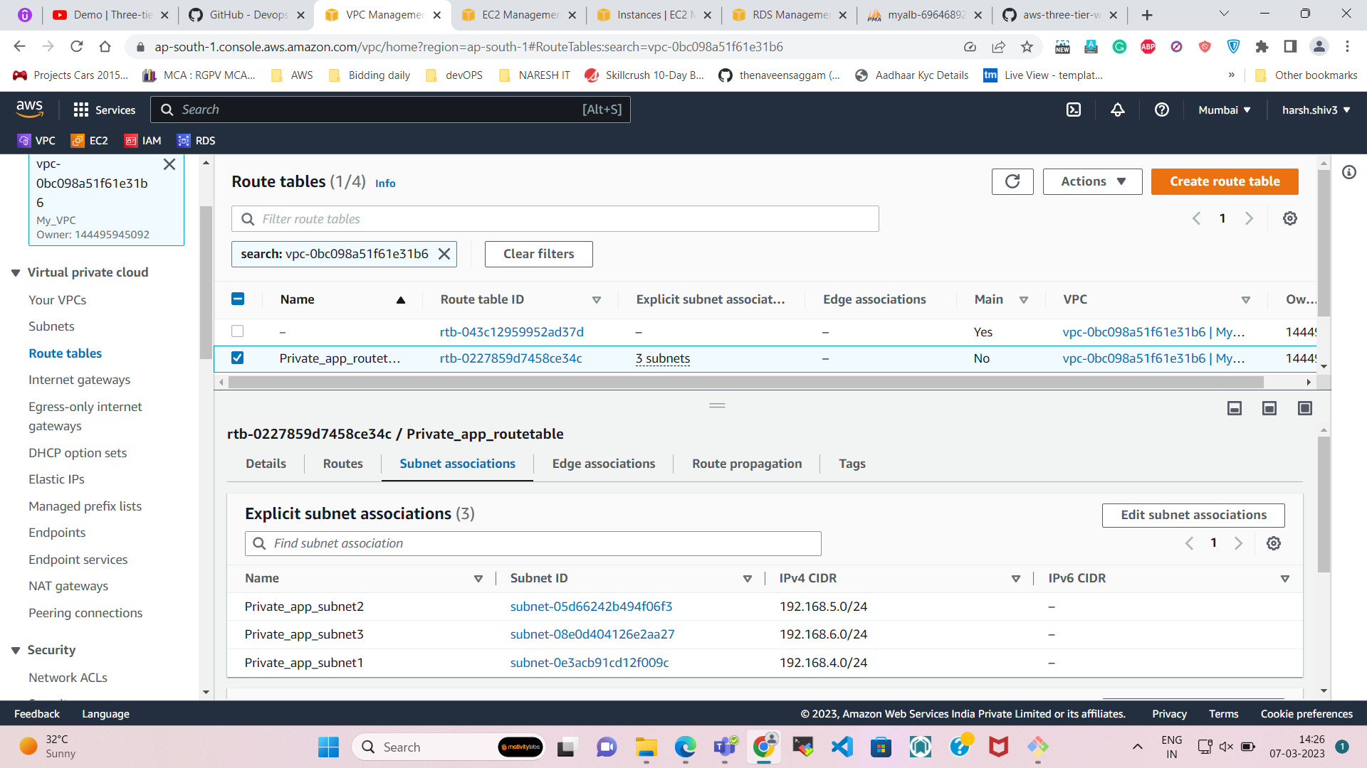

* **Private DB route with Private DB subnet.**

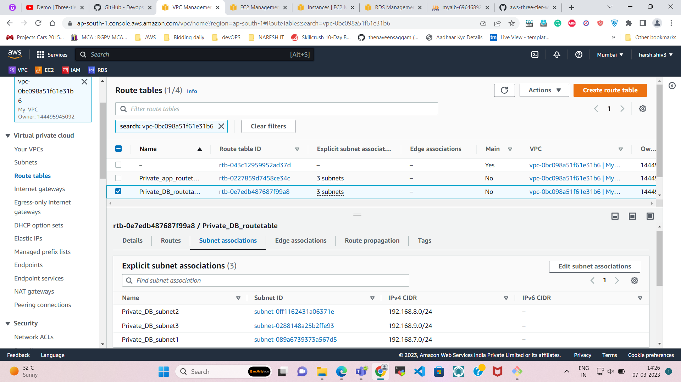

NOW we need to **create three EC2 Instances** with our **own VPC**.

1. **Name as Public_webserver1**  
   - Select our own VPC  
   - Select Subnet (PUBLIC WEB SERVER1) & auto assign IP (ENABLE)  
   - Create a new SG- SSH only with custom source.  
   - Create a new key-pair & launch the instance.

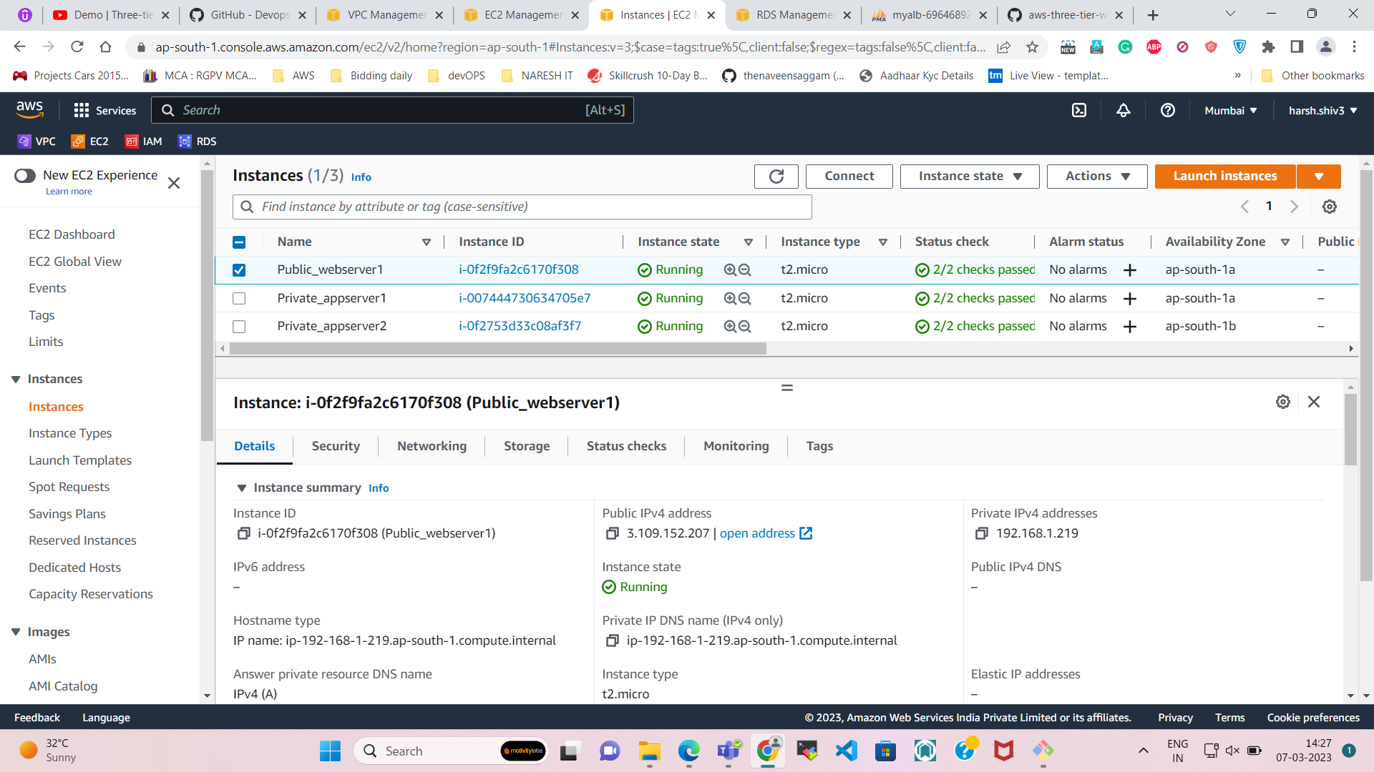

Details of my instance.

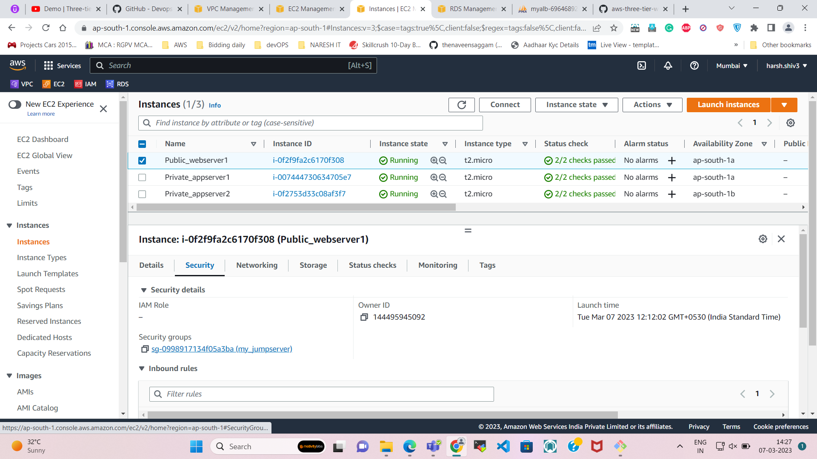

Security Groups of my **public web server** instance.

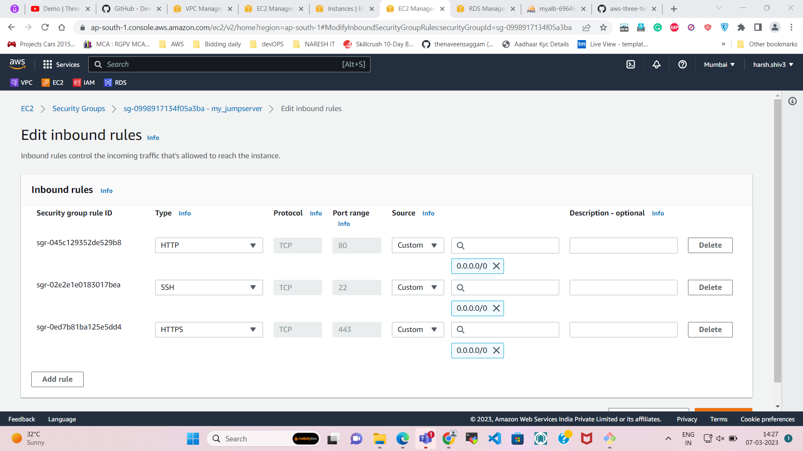

1. **Name as Private_appserver1**  
   - Select our own VPC  
   - Select Subnet (PRIVATE APP SERVER1)  
   - Create a new SG- SSH only with custom source (**SG of PUBLIC WEB SERVER1**).  
   **\*\*Only allow the access from the JUMP Server**   
   - Select the same Key-pair & launch the instance.

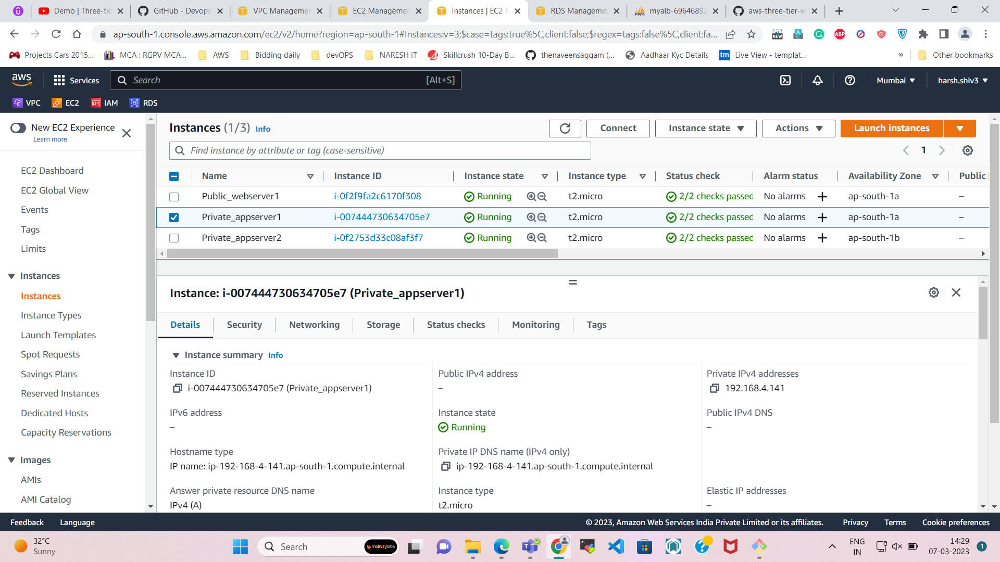

Details of my instance.

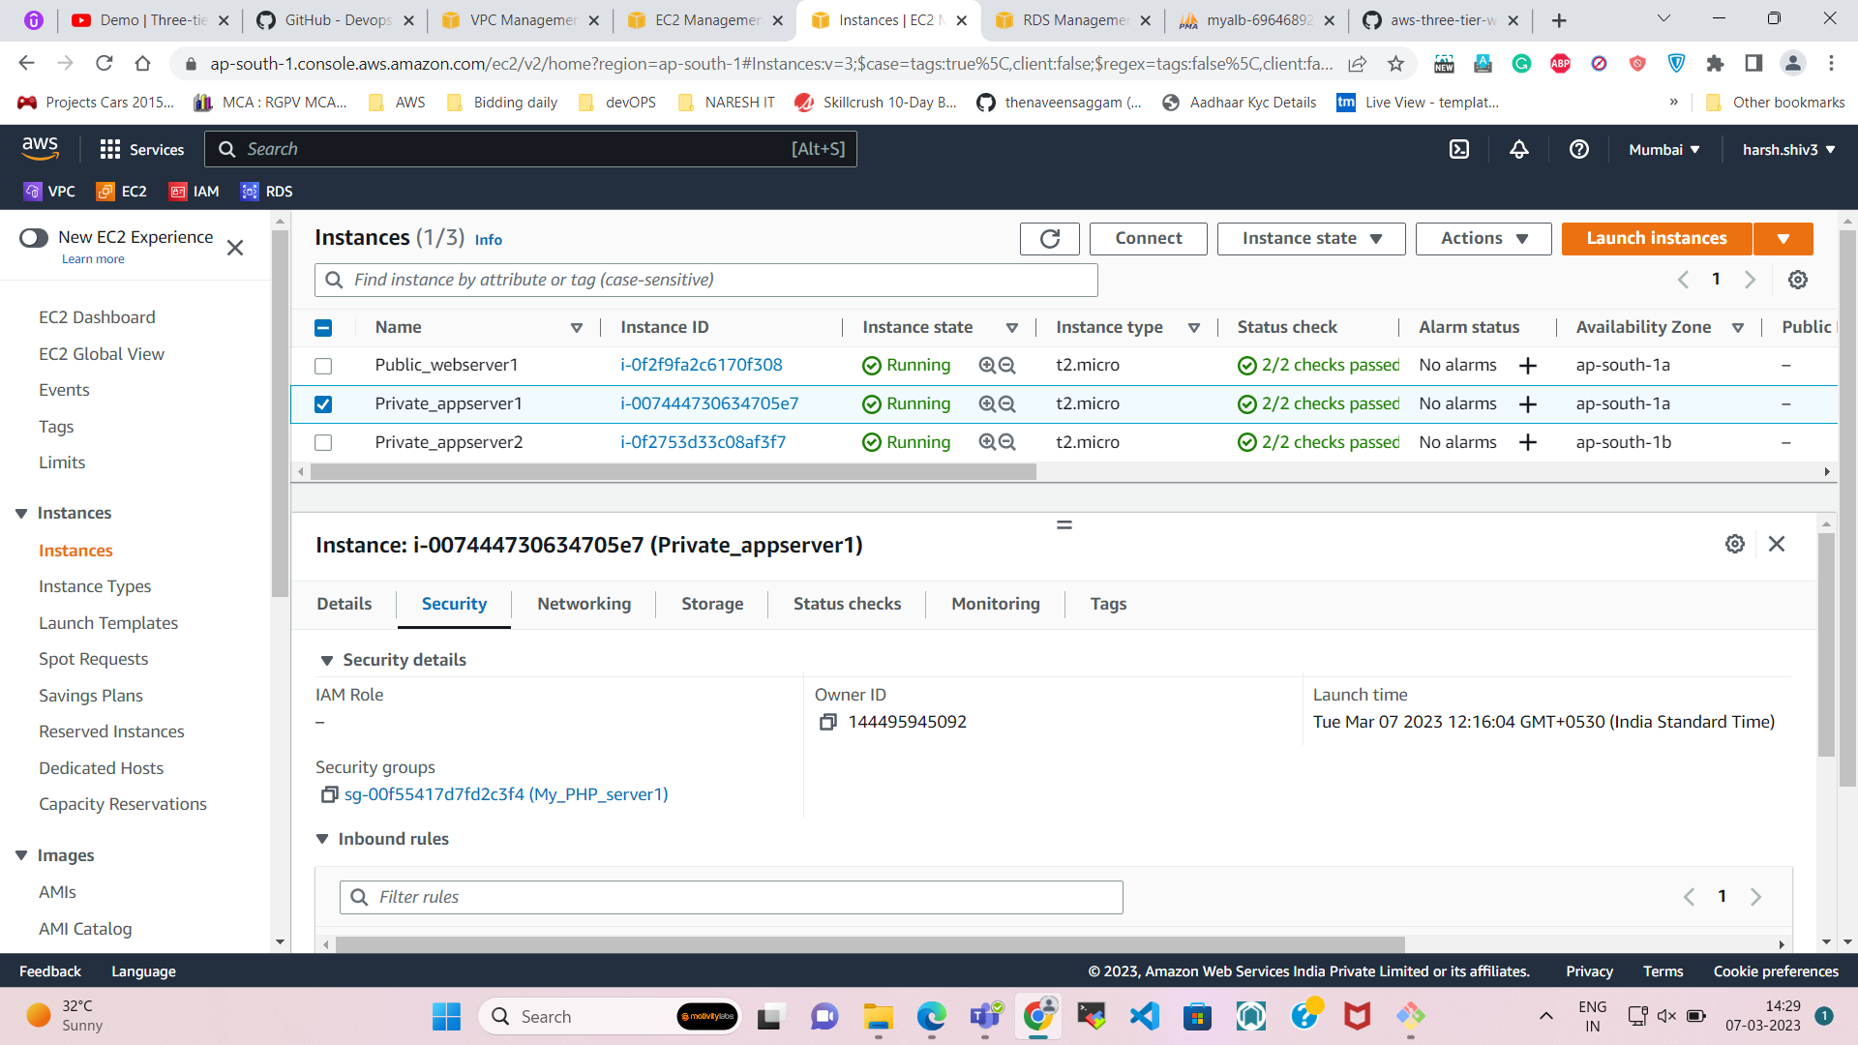

Security Groups of my **private app server** instance.

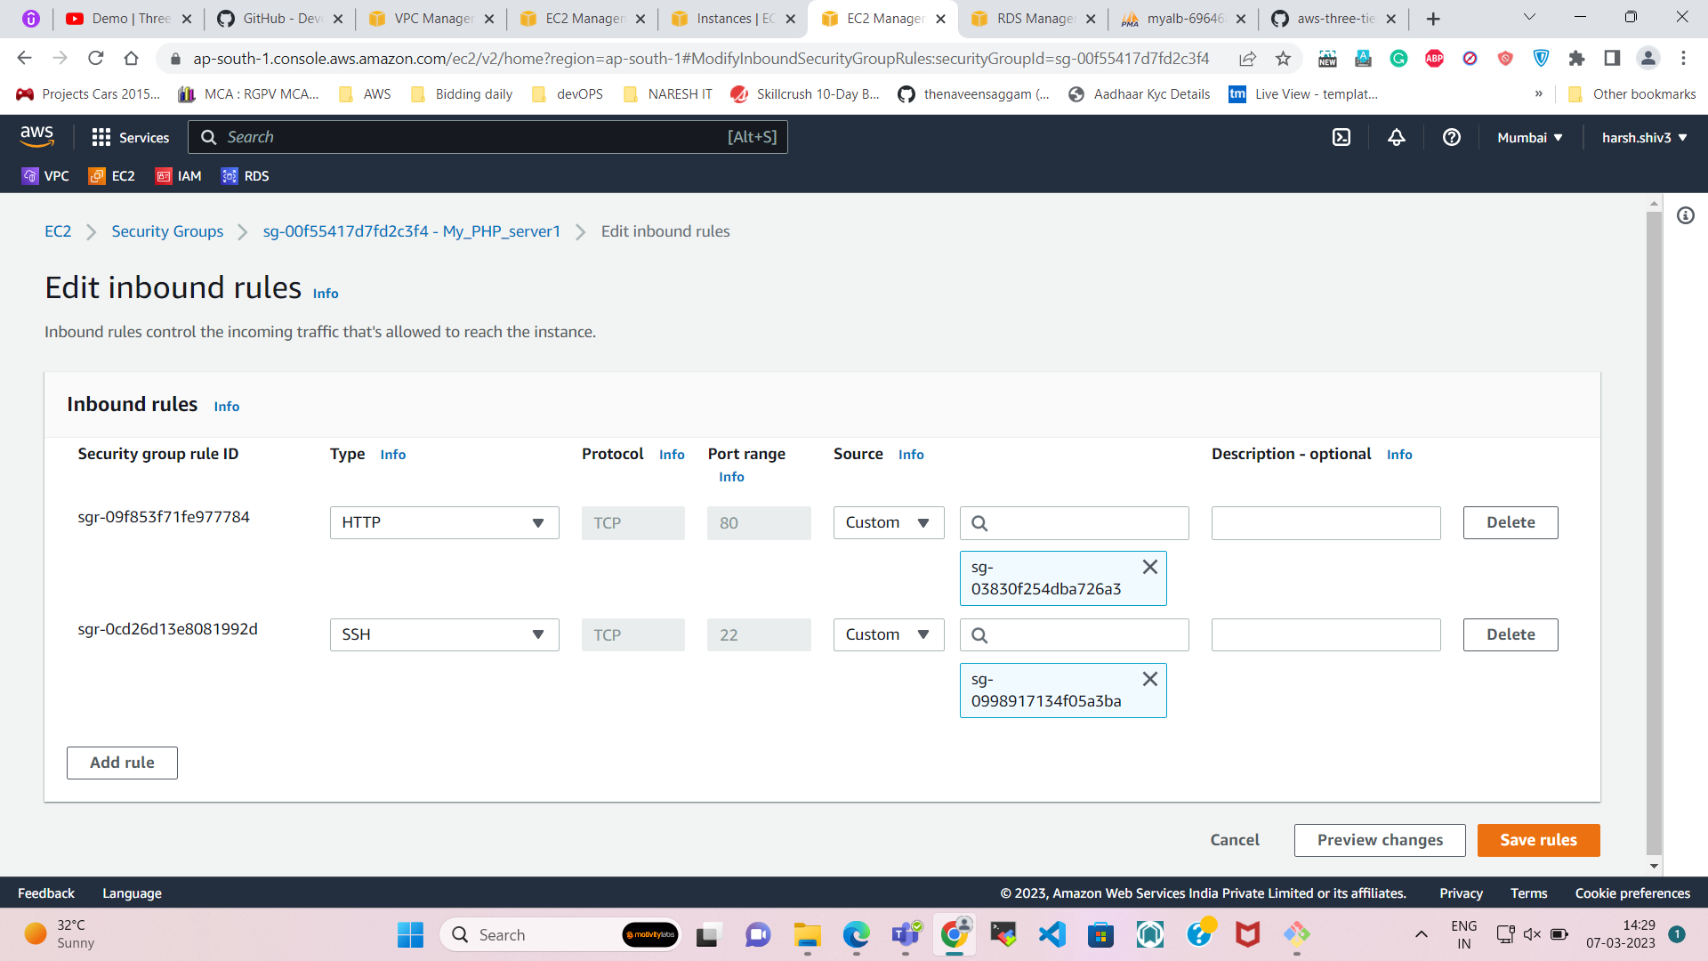

1. **Name as Private_appserver2**  
   - Select our own VPC  
   - Select Subnet (PRIVATE APP SERVER2)  
   - Create a new SG- SSH only with custom source (**SG of PRIVATE APP SERVER1**).   
   - Select the same Key-pair & launch the instance.

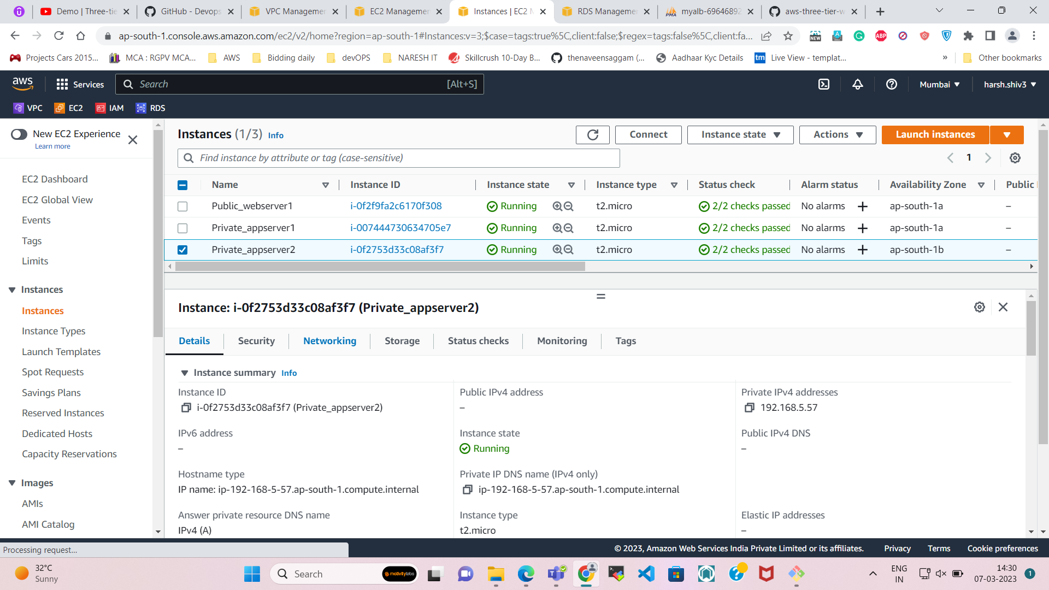

Details of my instance.

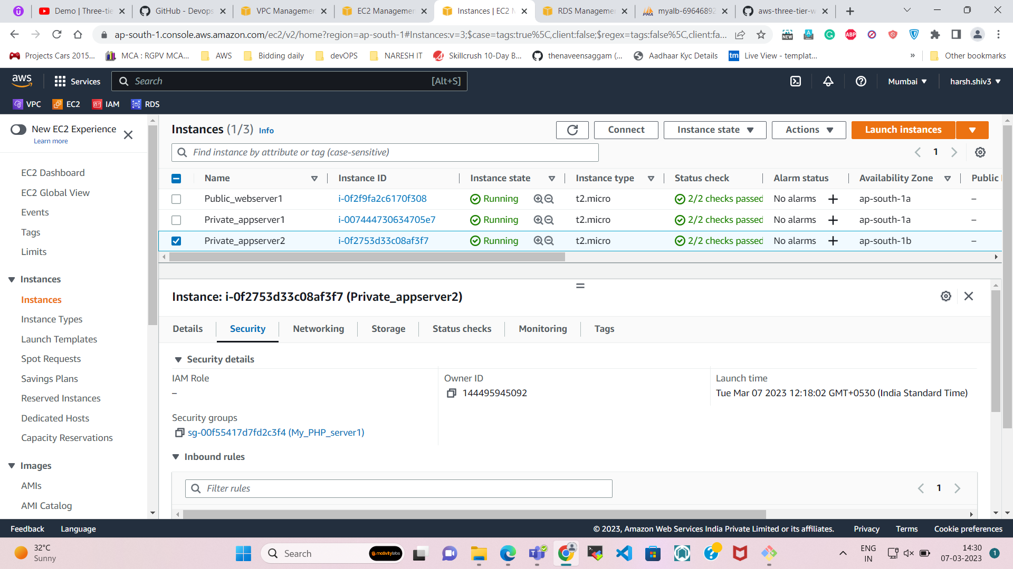

**Now Connection part is completed.**  
  
**===========================================================================**  
**Step-7**  
  
**Let's jump into public web instance and connect it with the private app server 1**

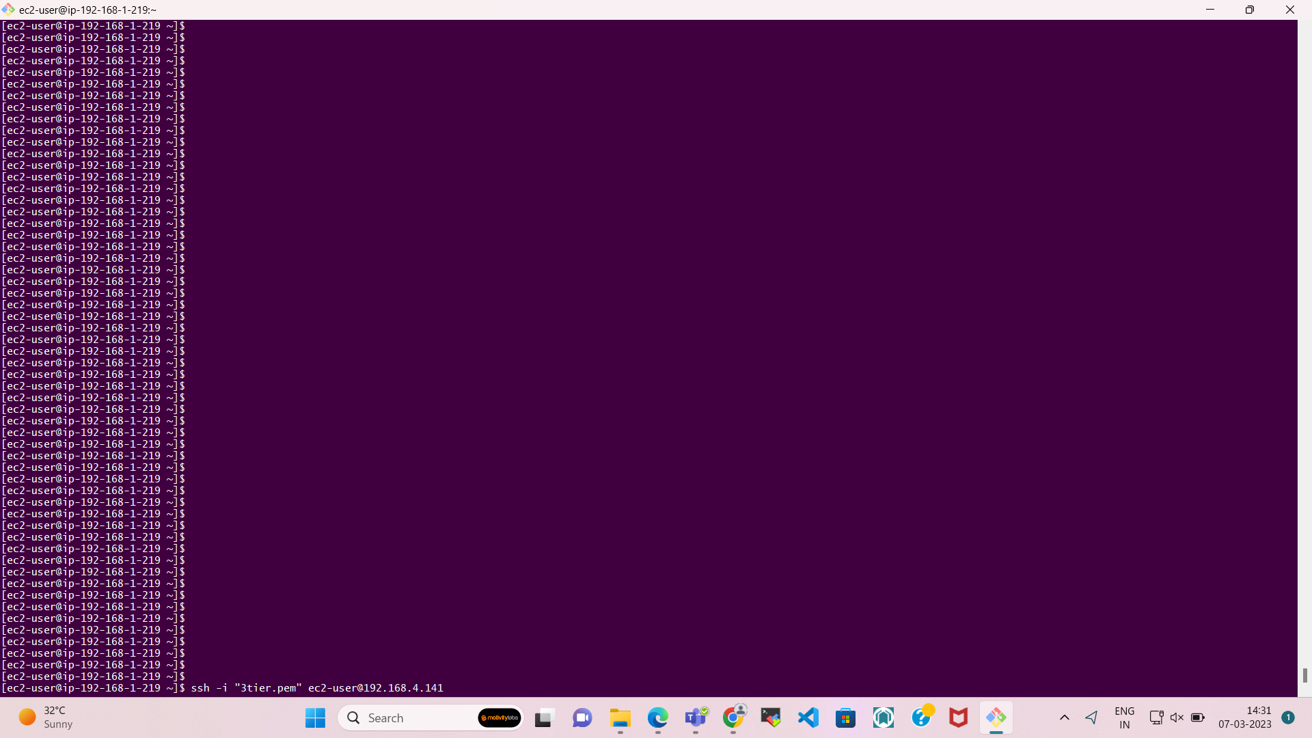

**USE the COPY Command to copy the key from one server to another.**

**And after that try to login from public web subnet to private app sever.**

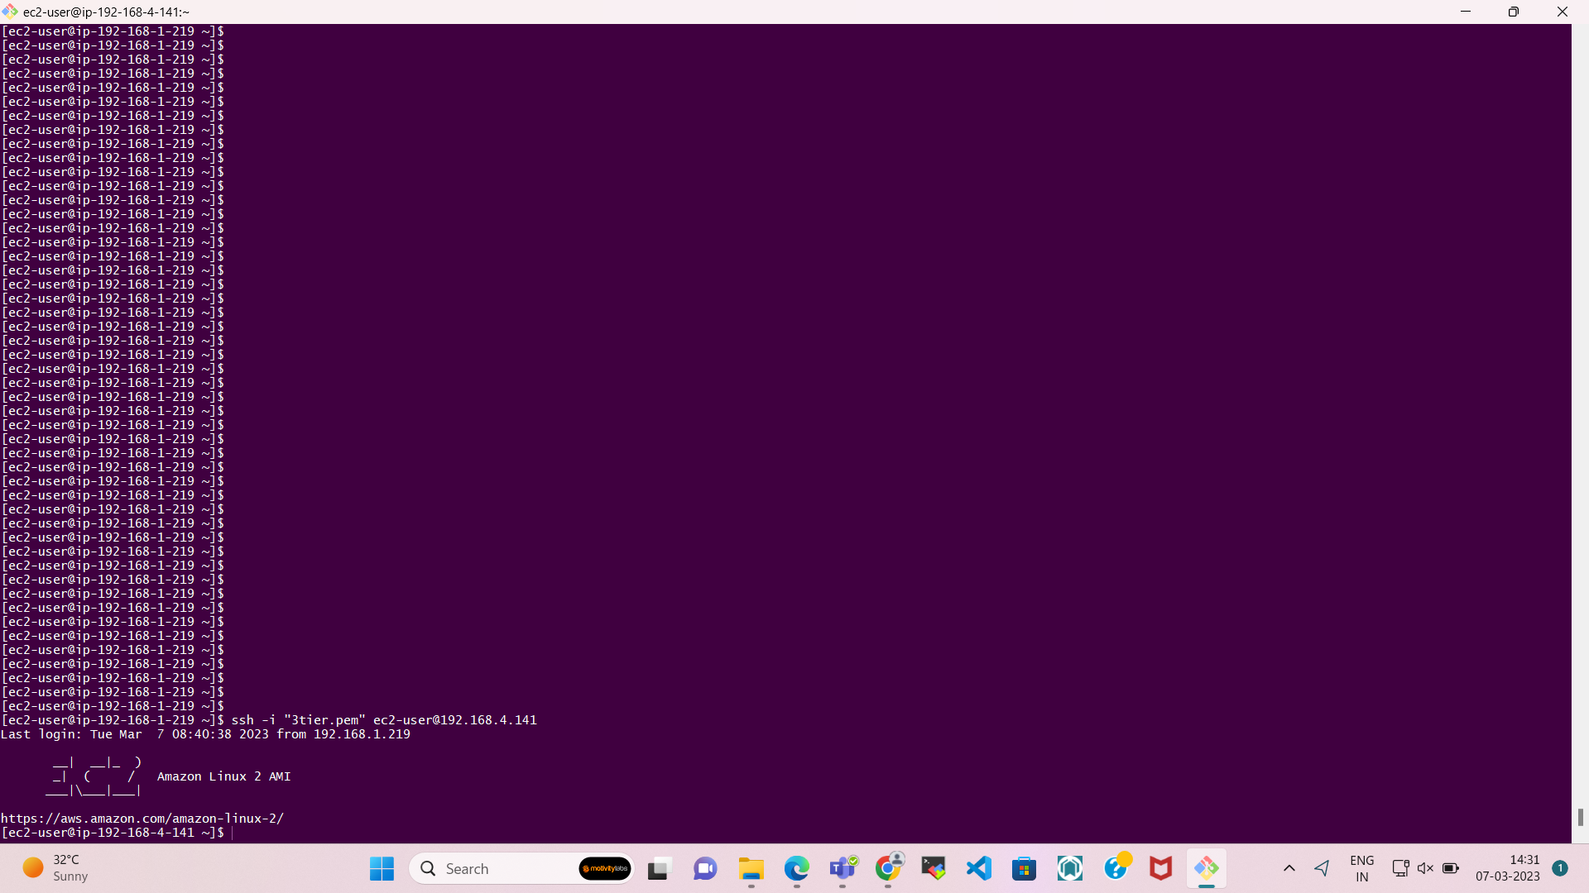

After successfully login, try to install the software which you will be required for the project   
  
**\*\*RUN EACH AND EVERY COMMAND ONE BY ONE CAREFULLY**

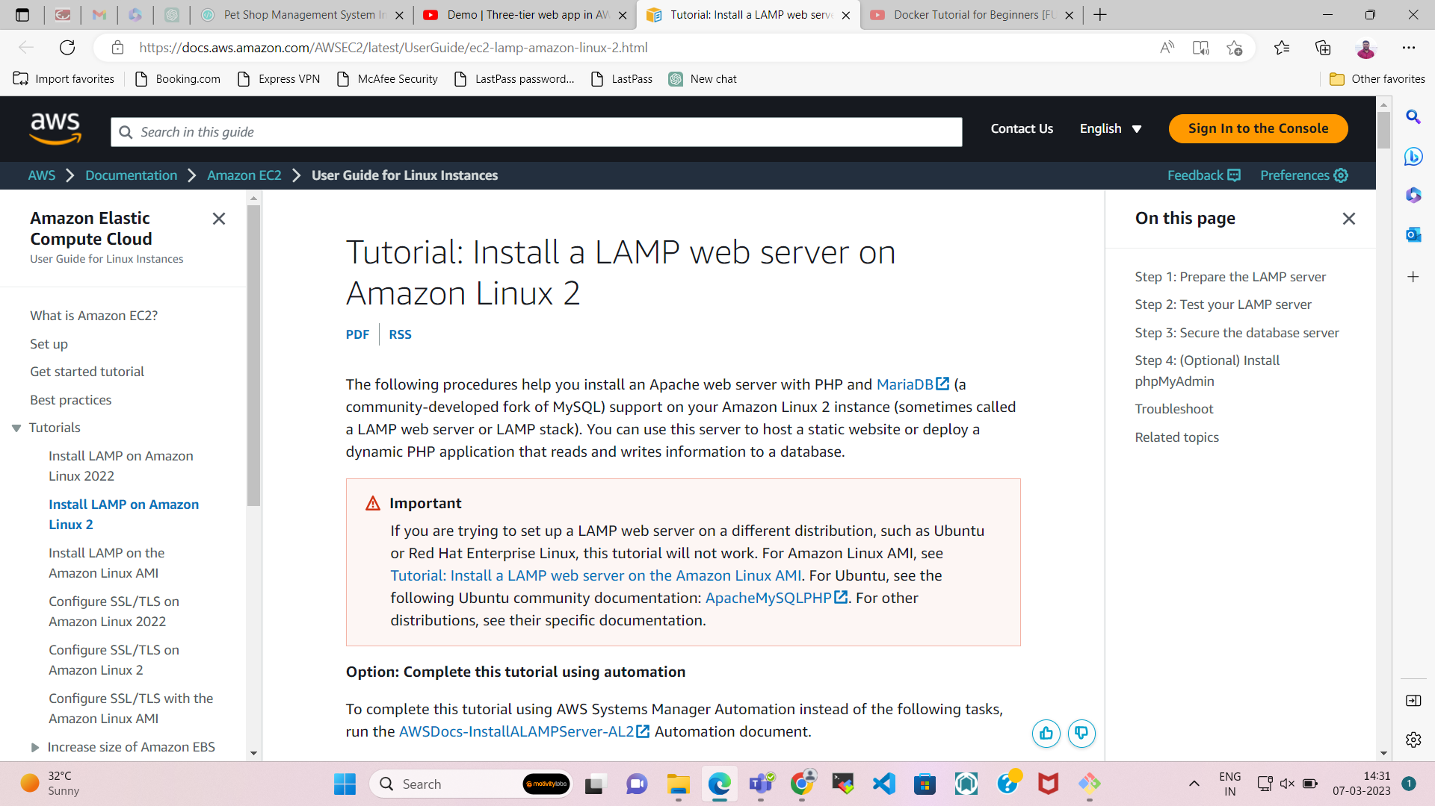

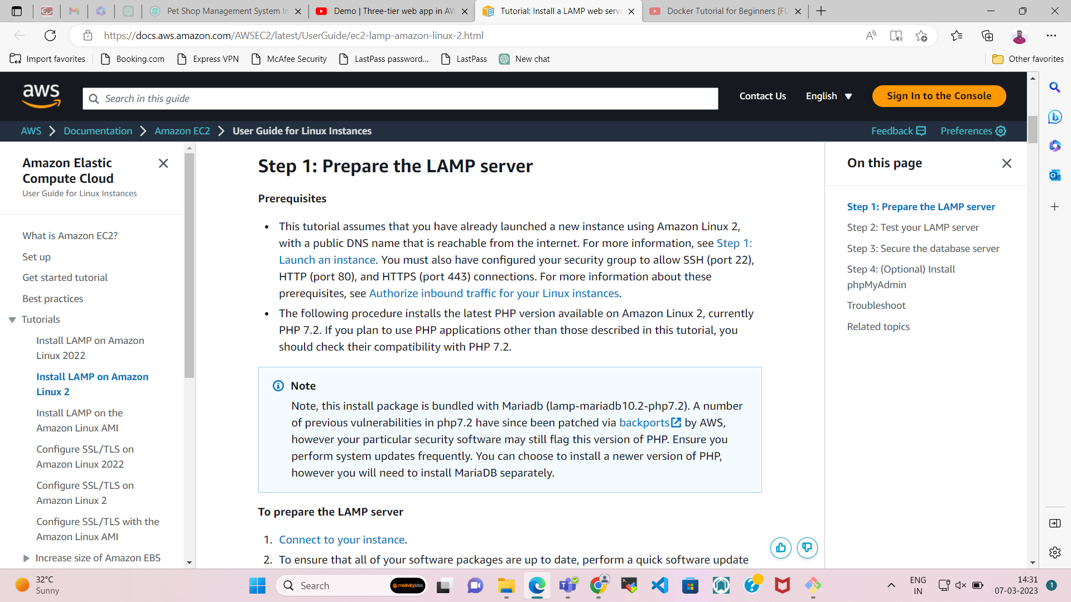

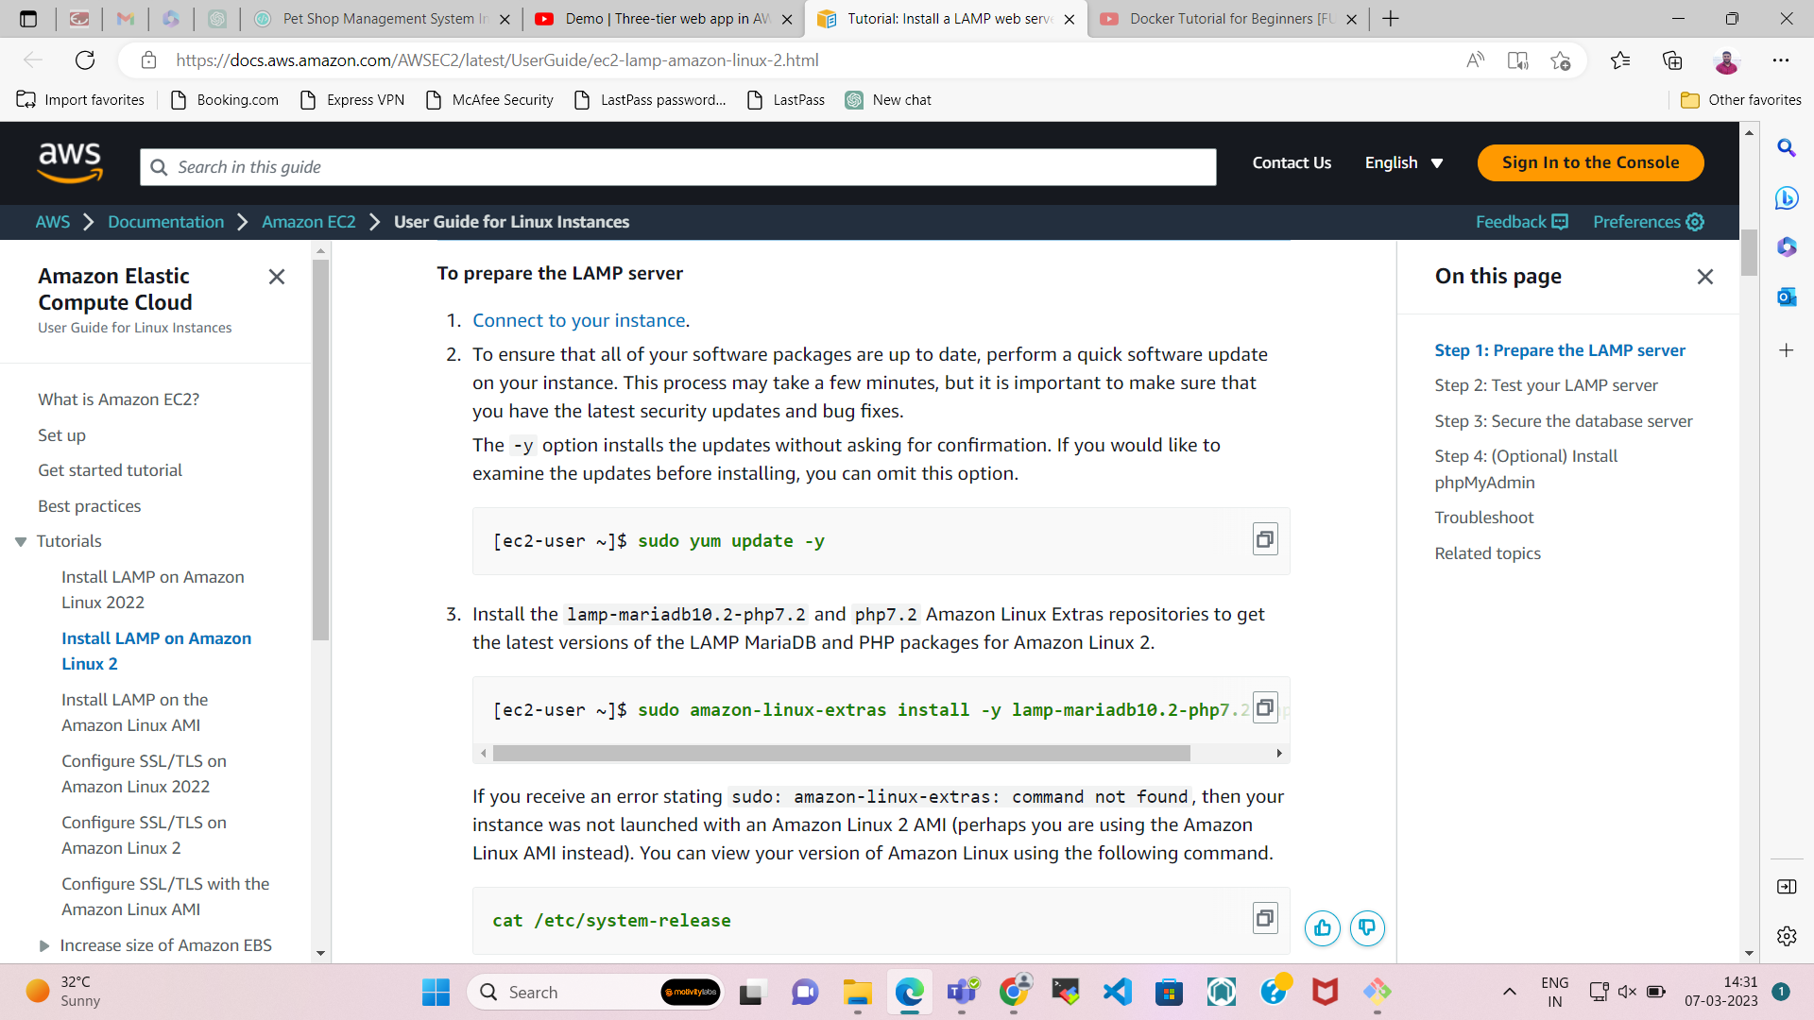

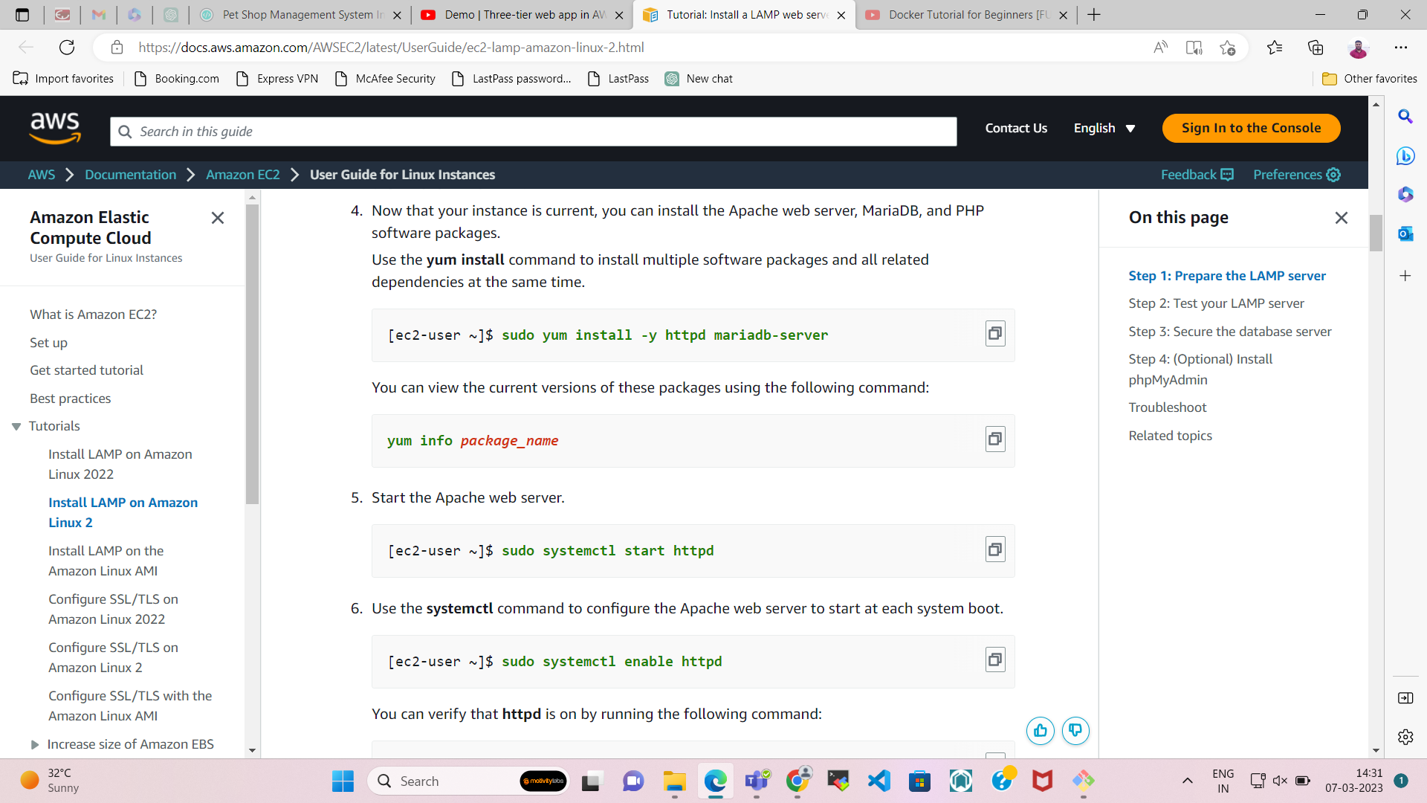

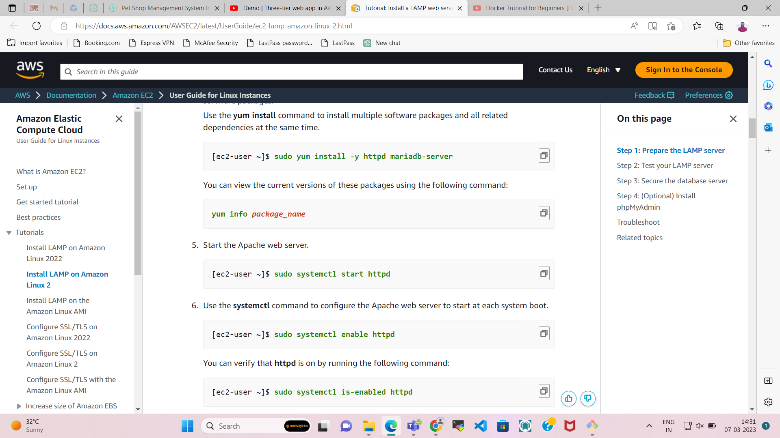

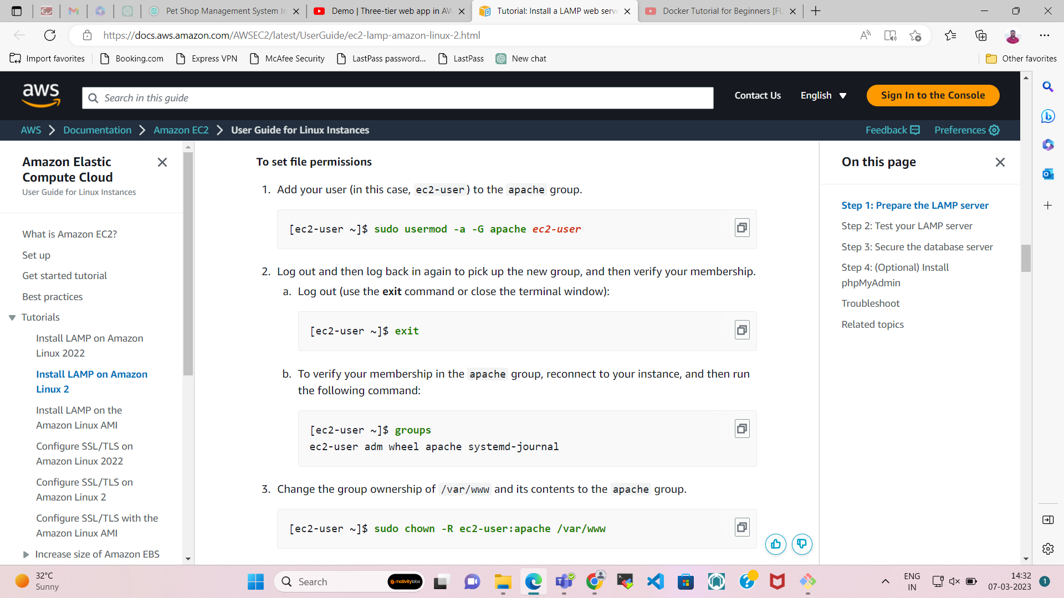

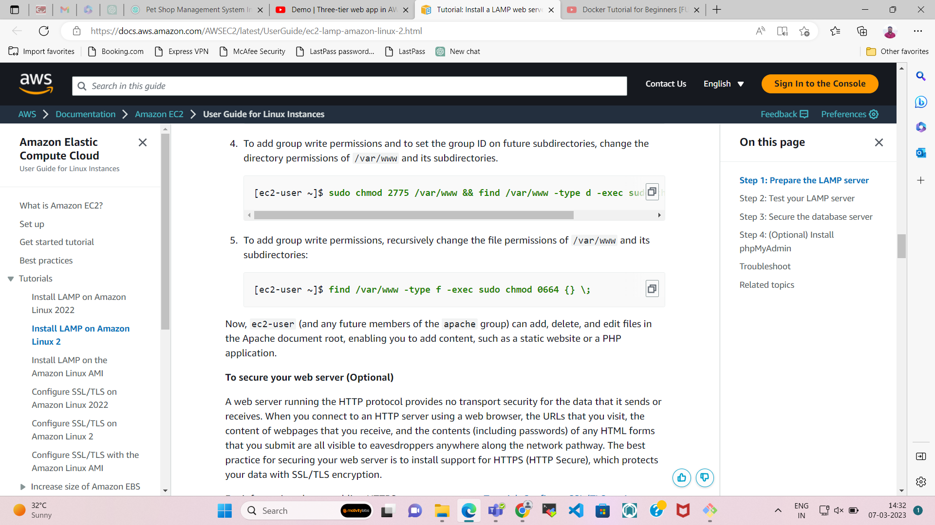

**Now Install phpMyAdmin for the project.**

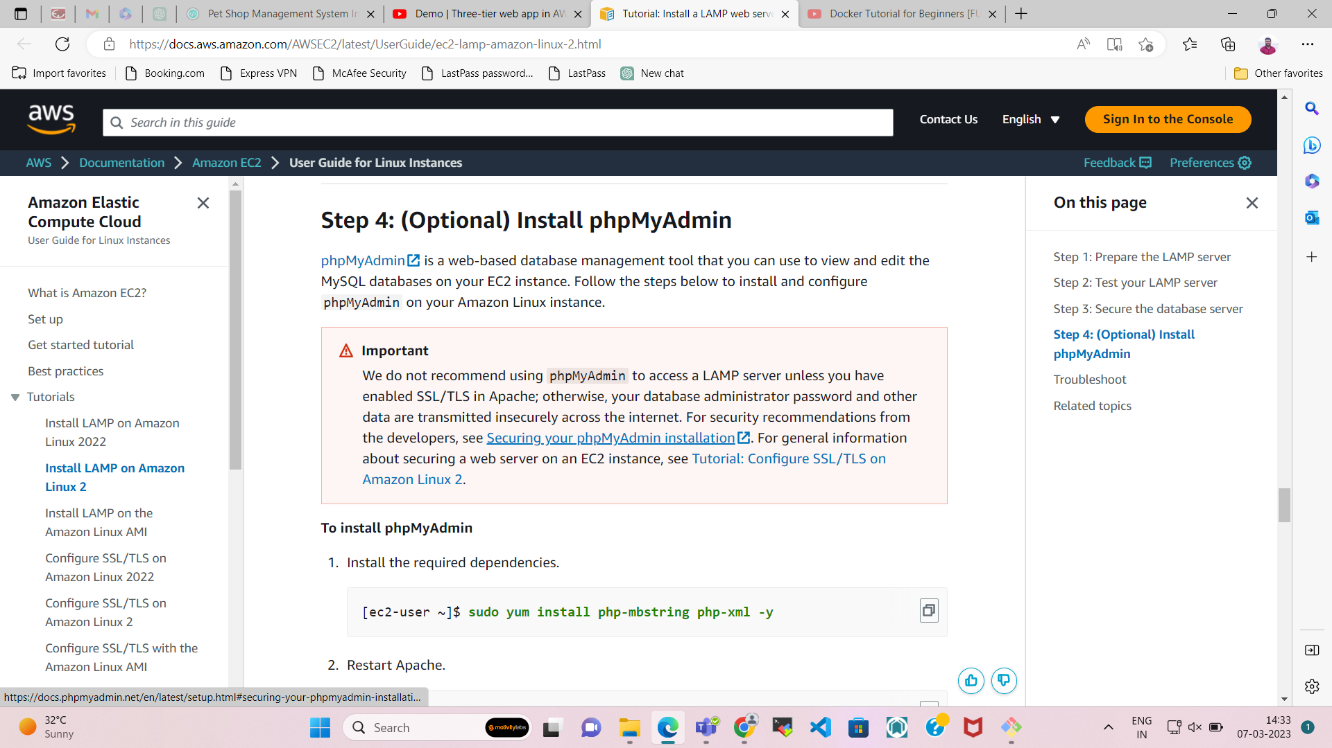

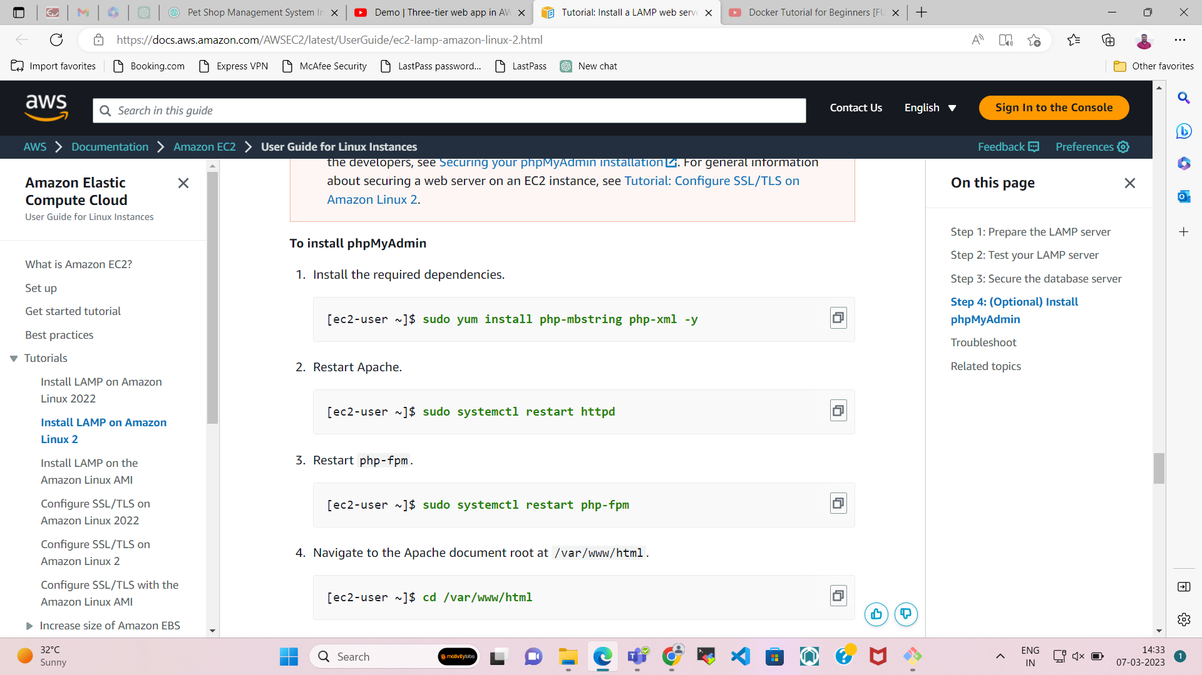

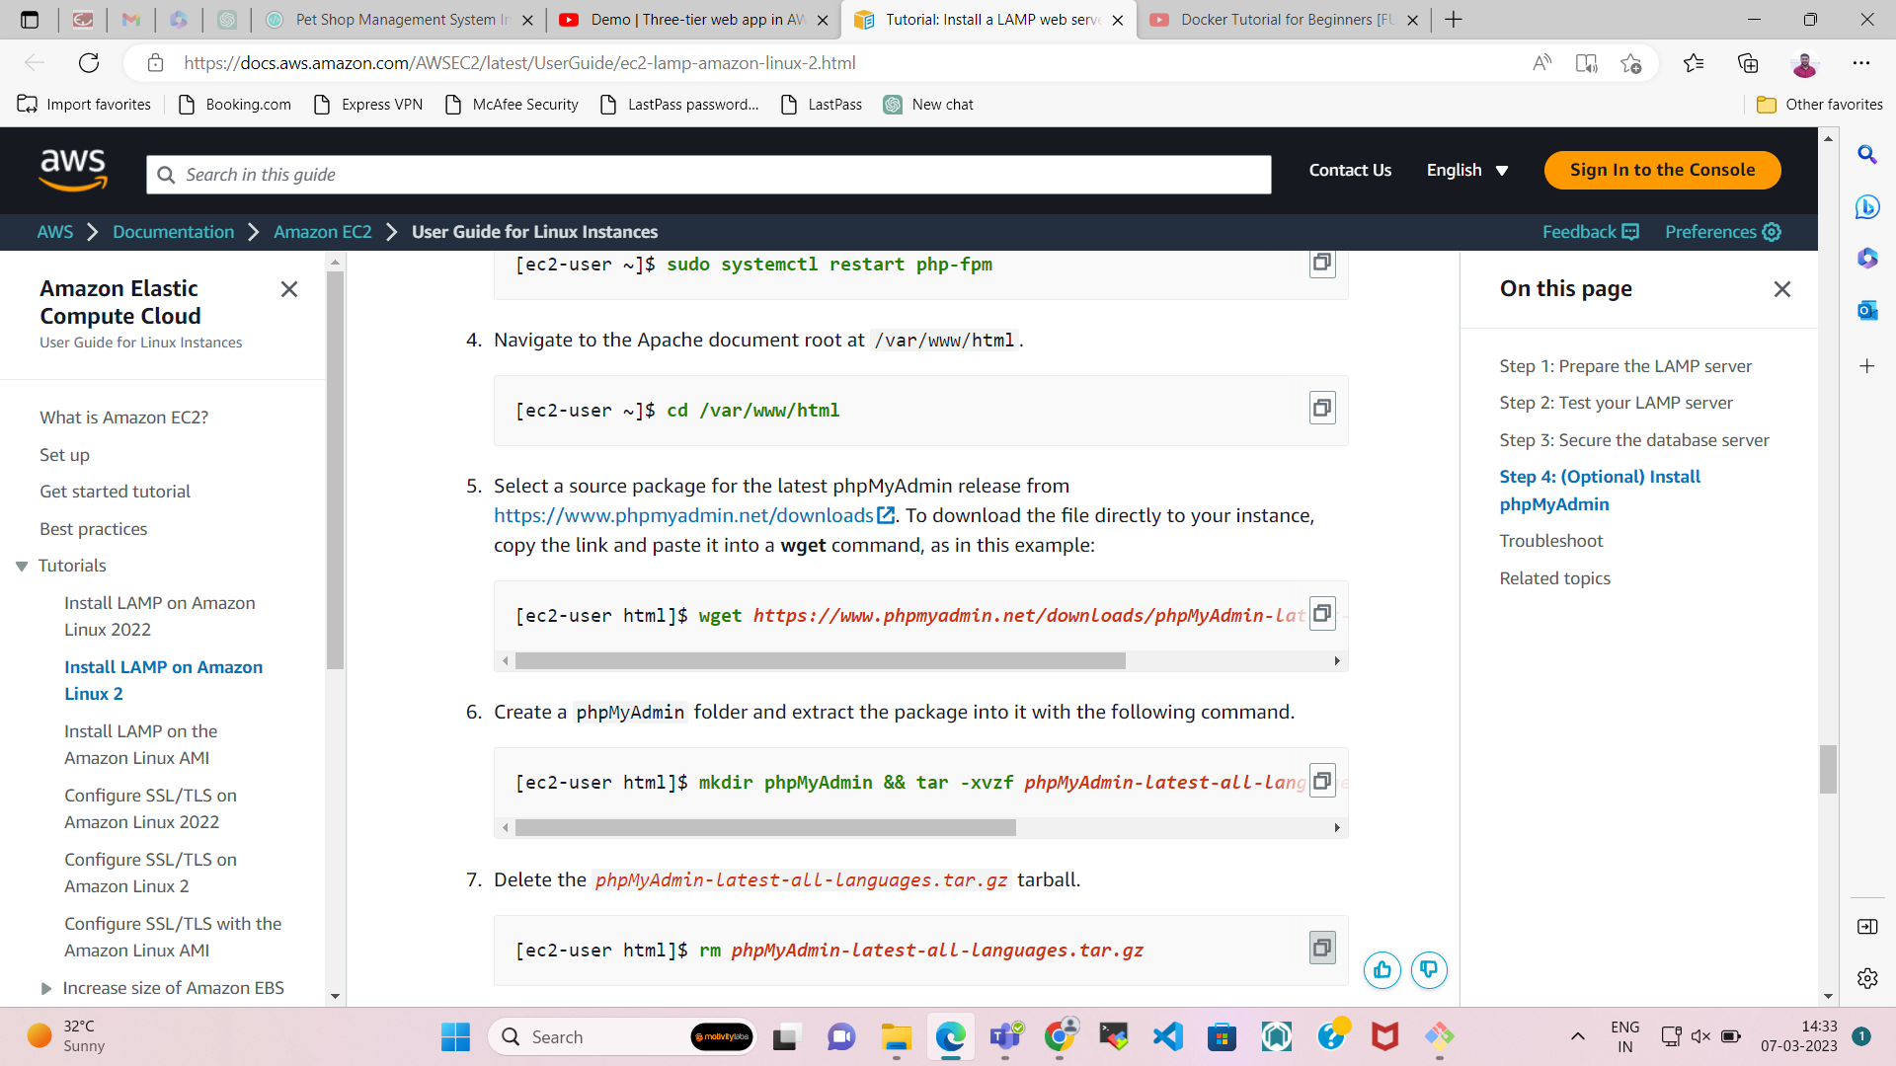

**Step-8**  
  
**Let check the HTTPD service is enabled & working or not.**

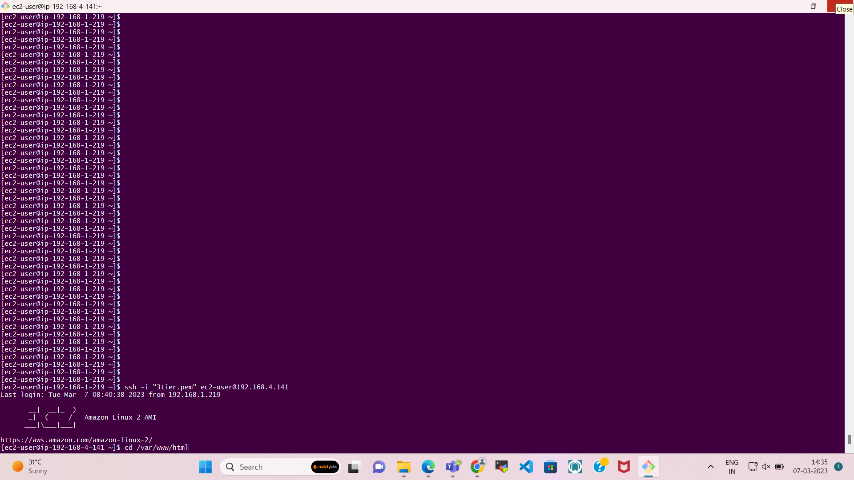

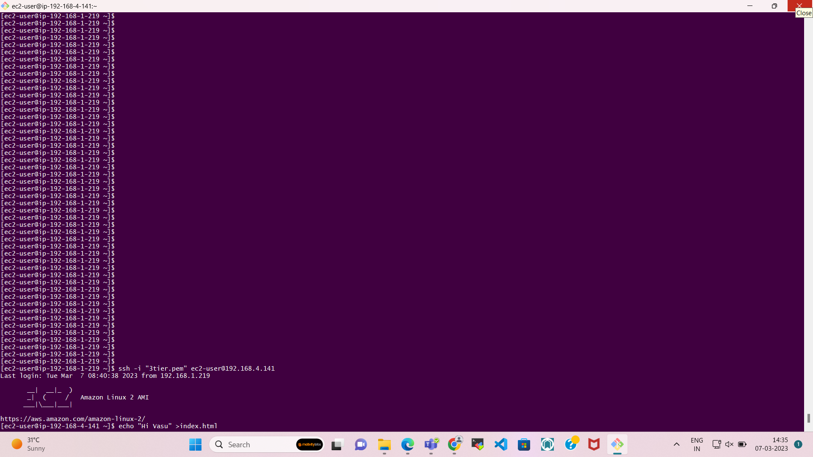

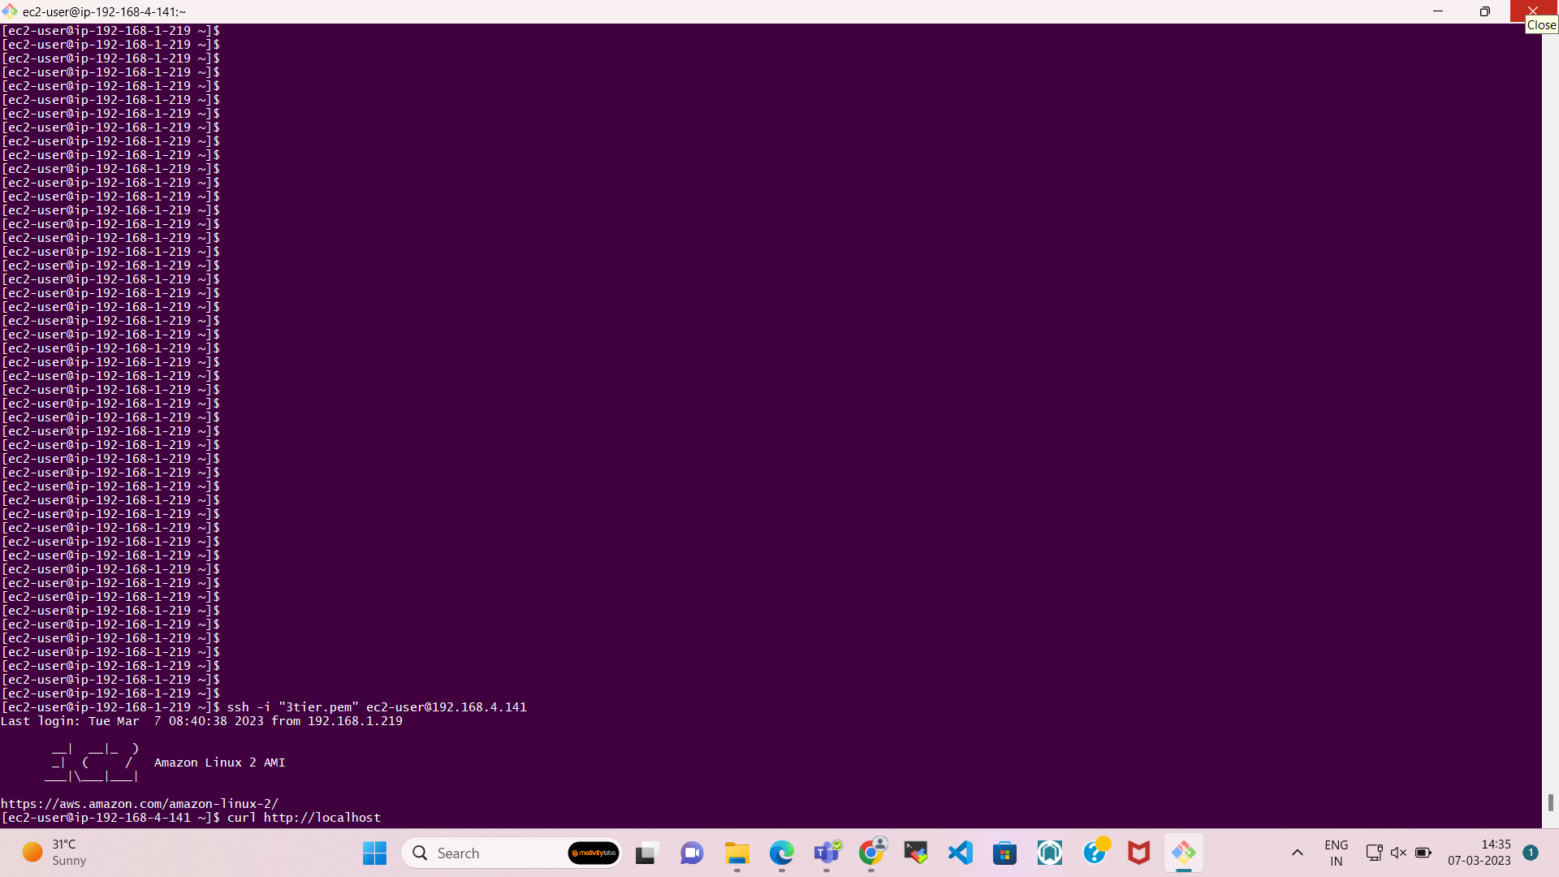

Here you can see I am getting output of HTPPD service in CMD.

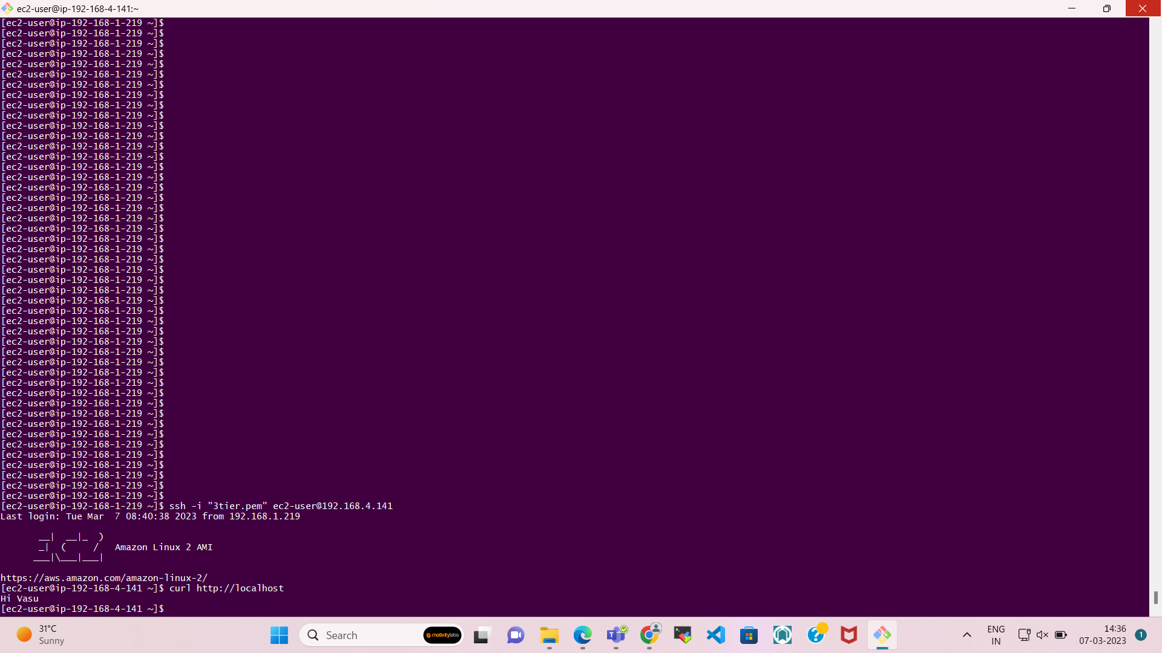

**Step-9**  
  
**Create and configure Application Load Balancer for the project.**

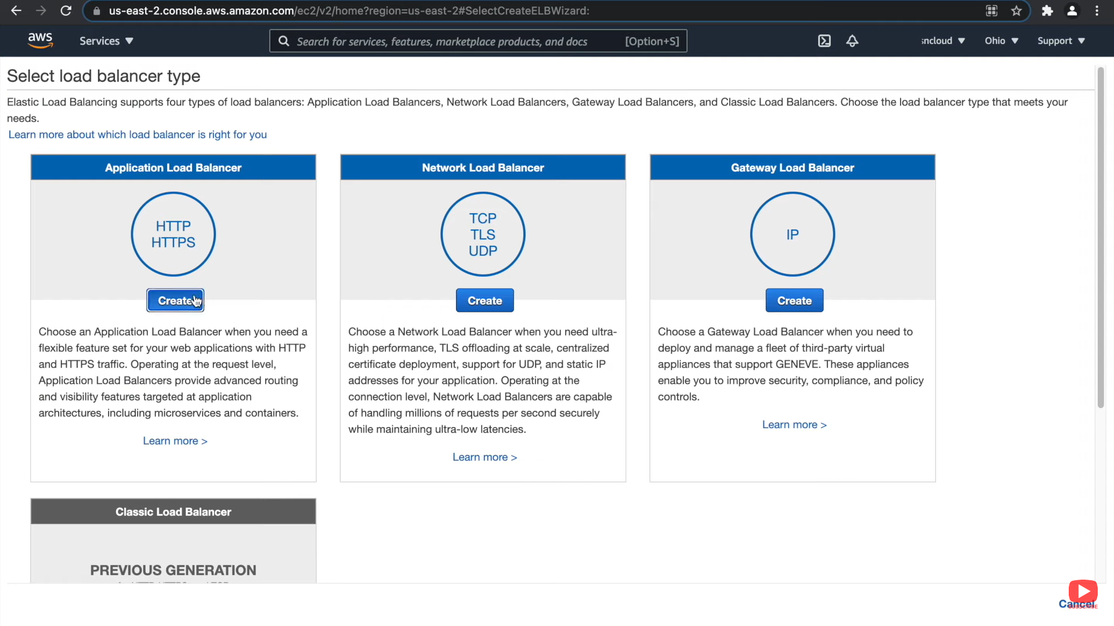

Do this process step by step.

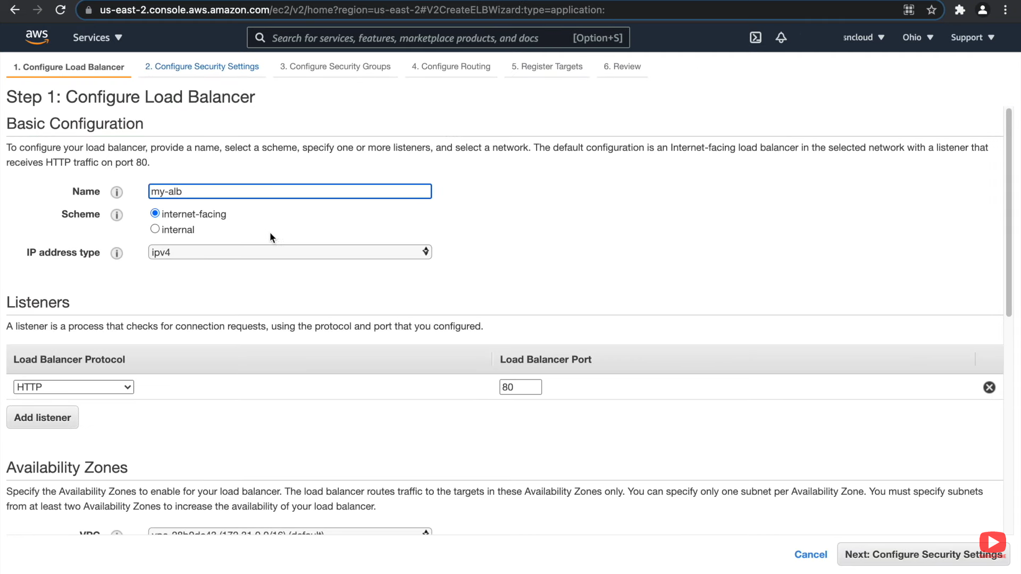

**Select our own VPC**

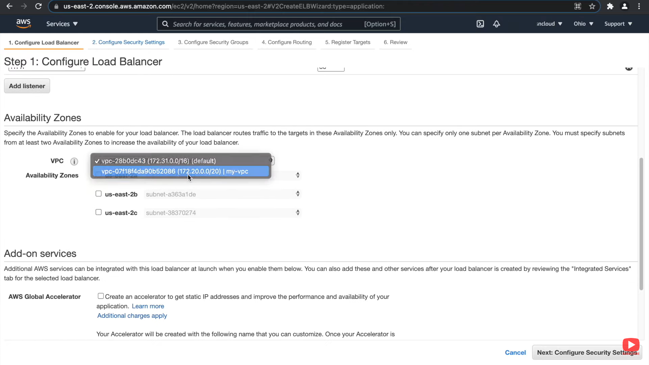

**Select PUBLIC SUBNETS**

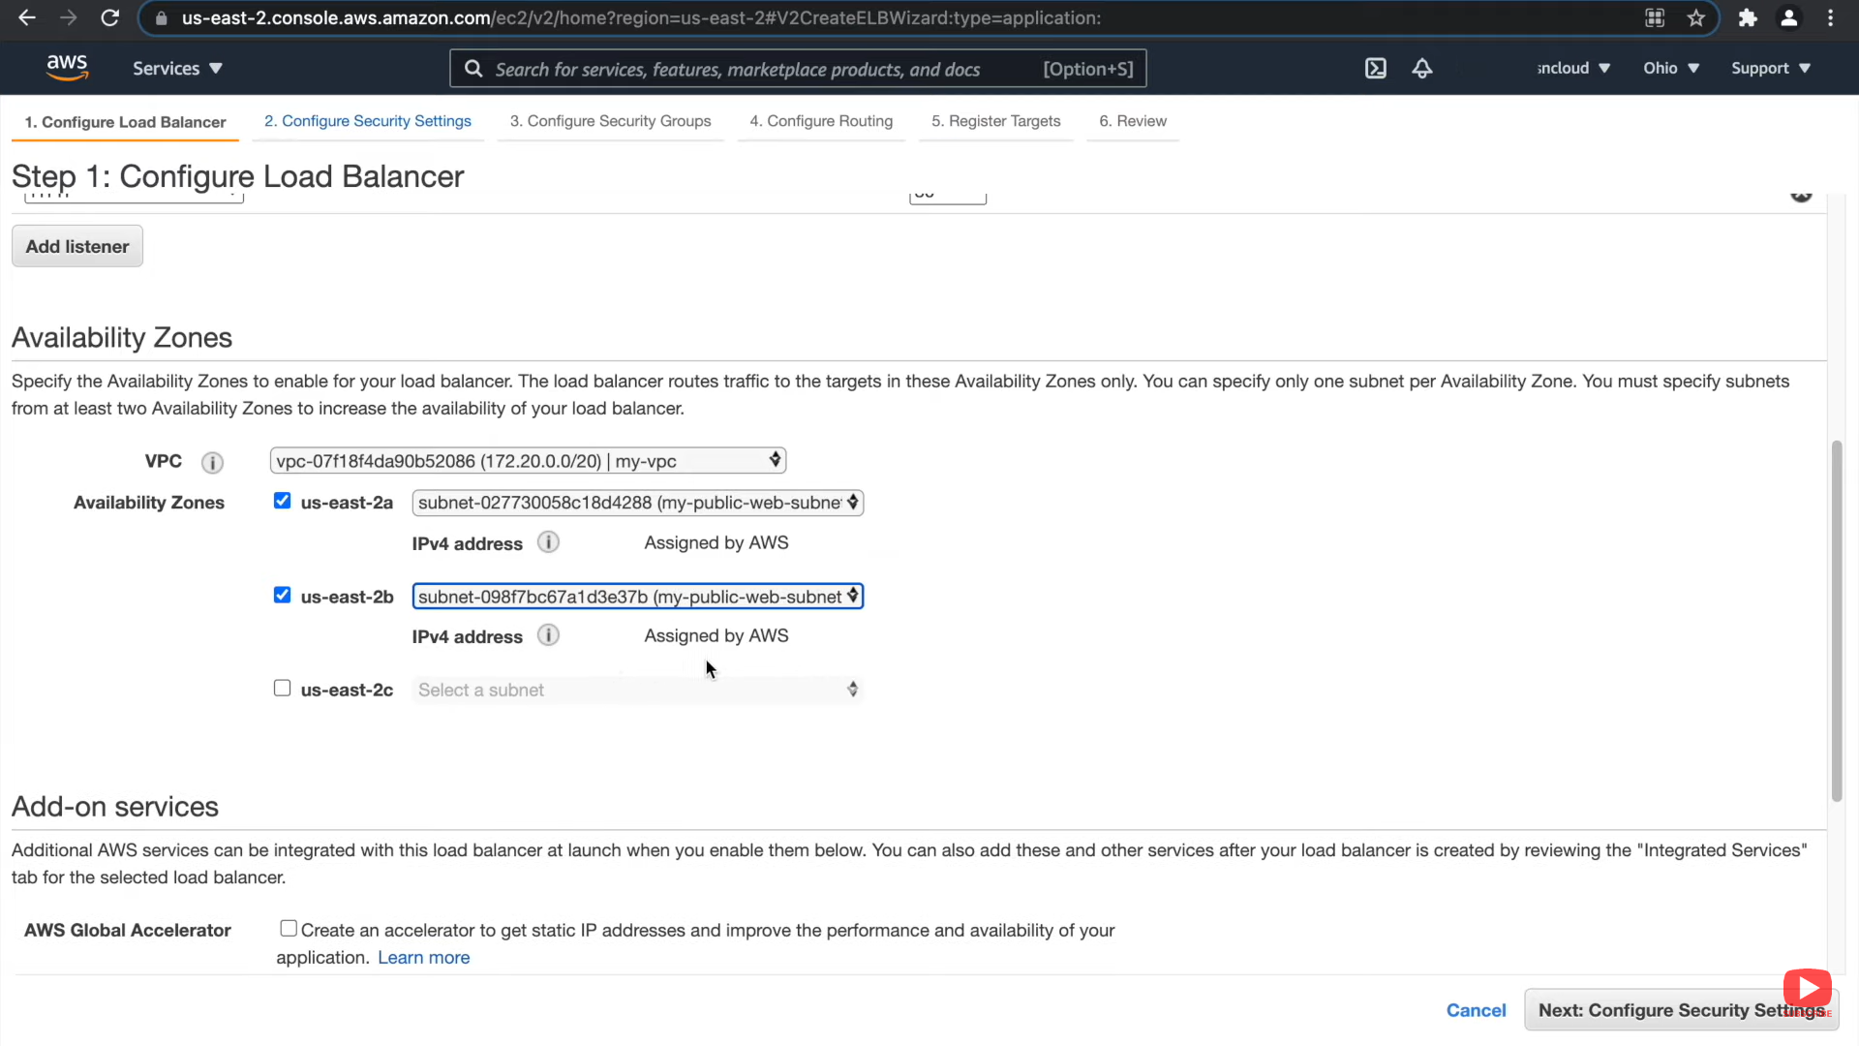

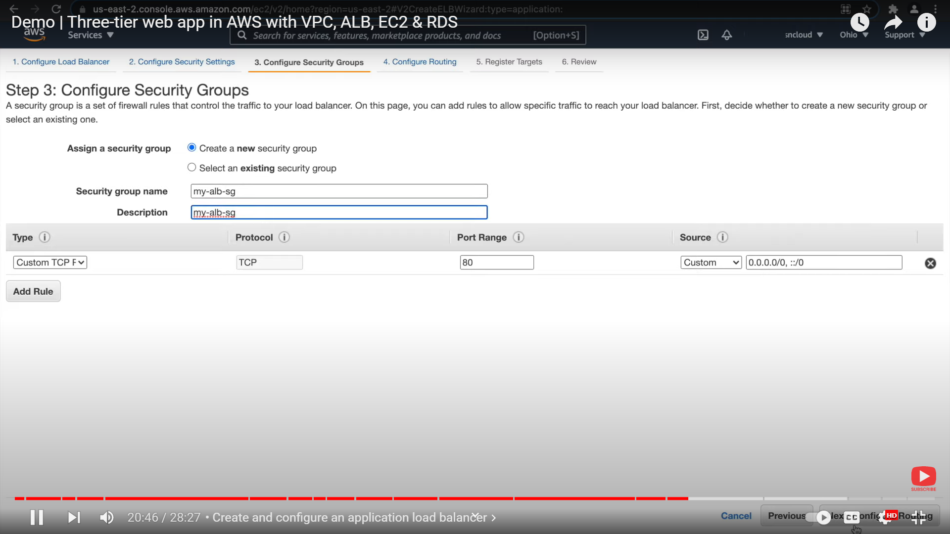

**See the details of my LB**

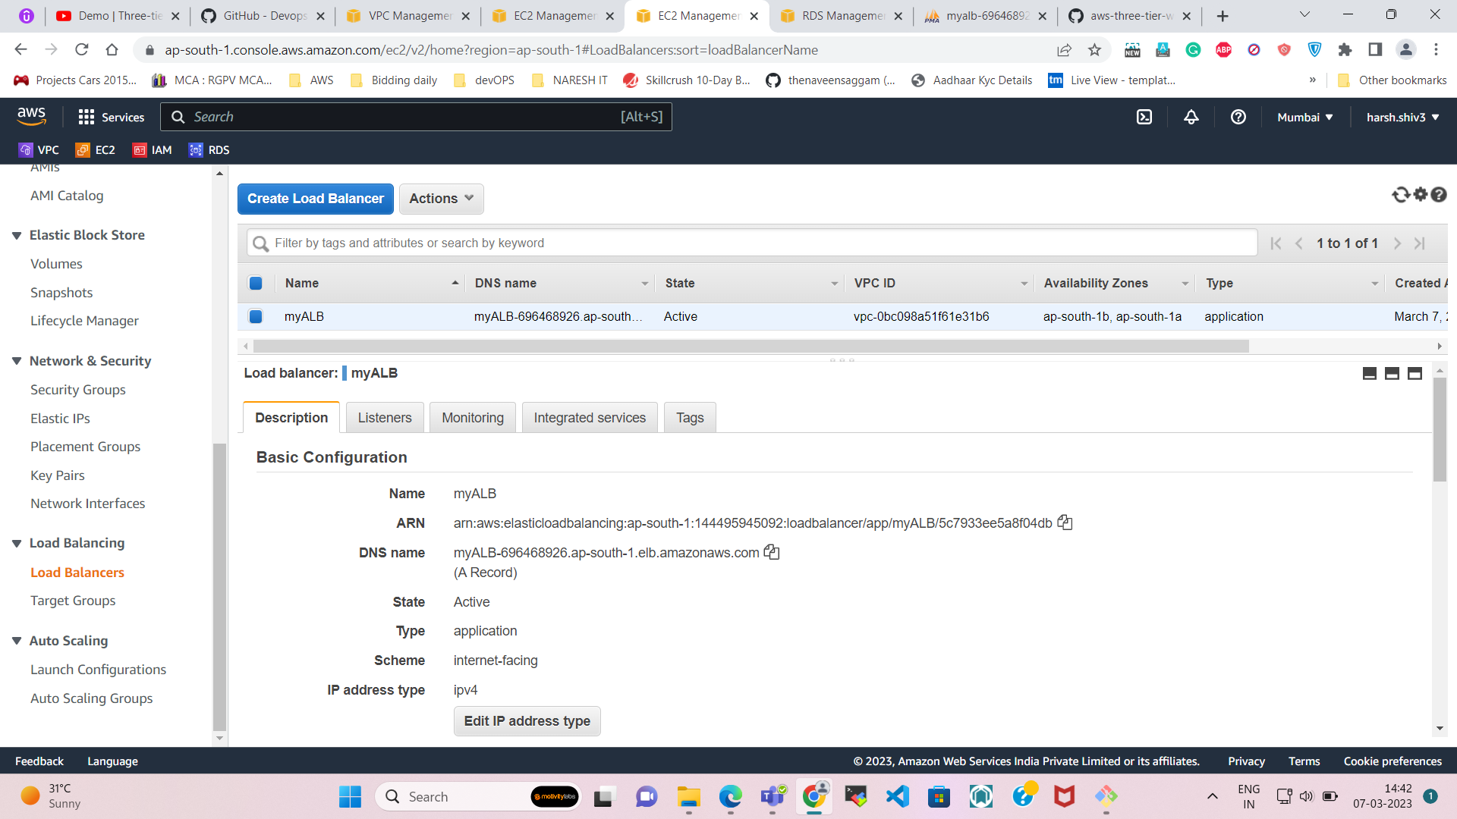

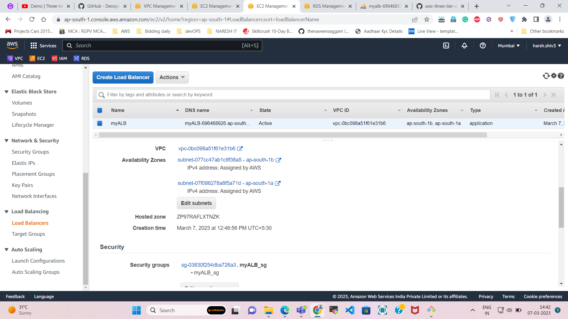

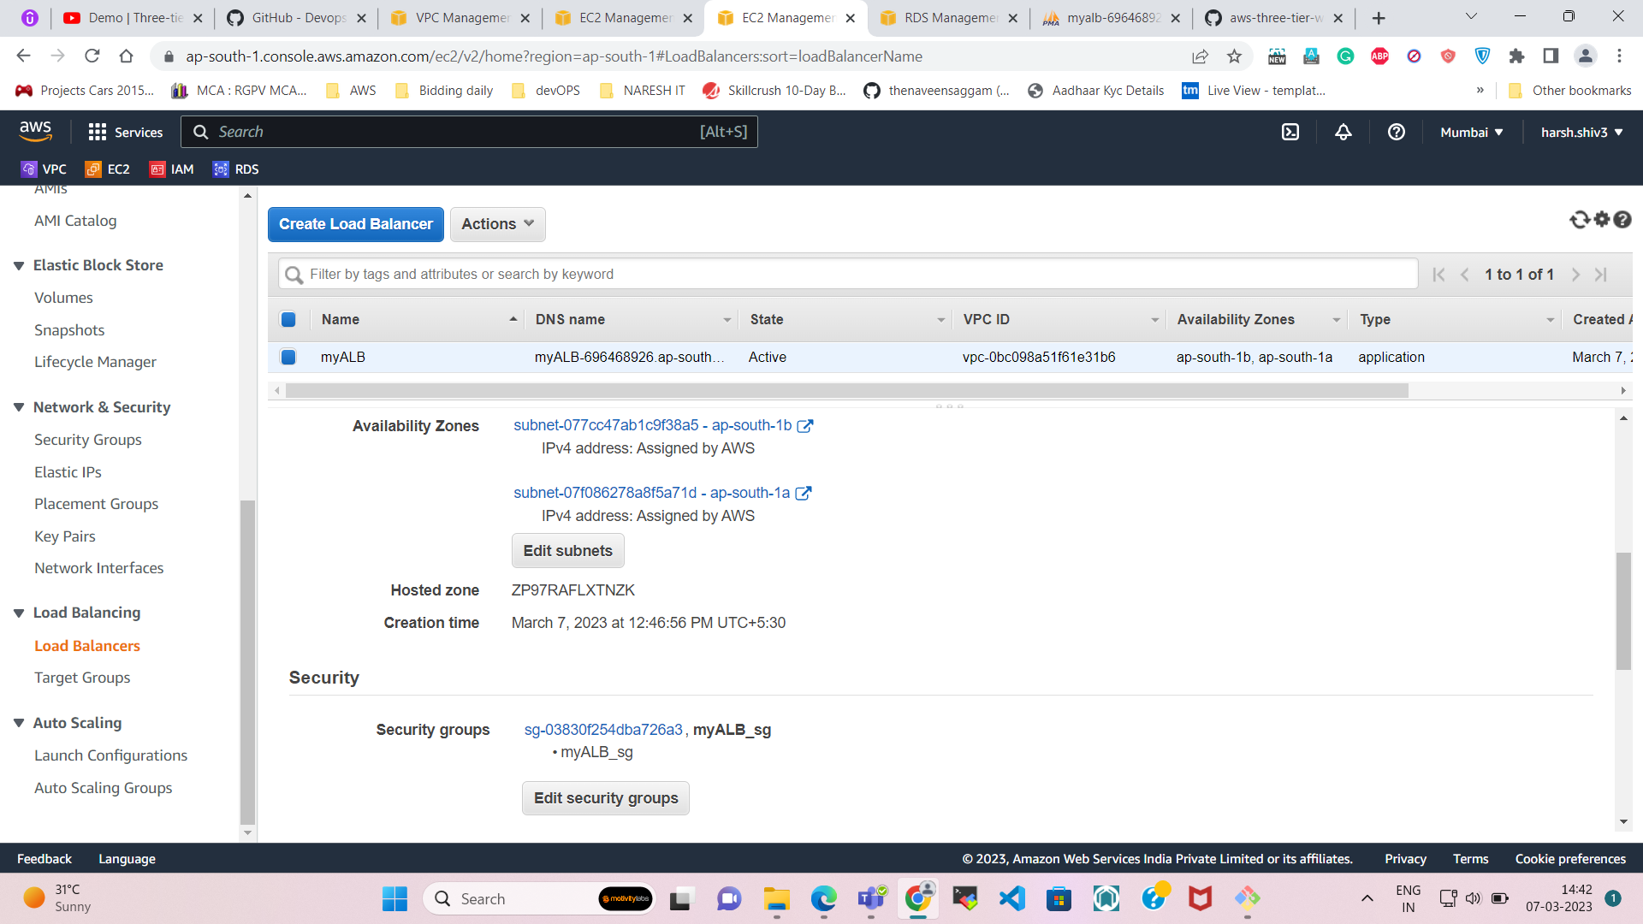

**Create the Target Group**

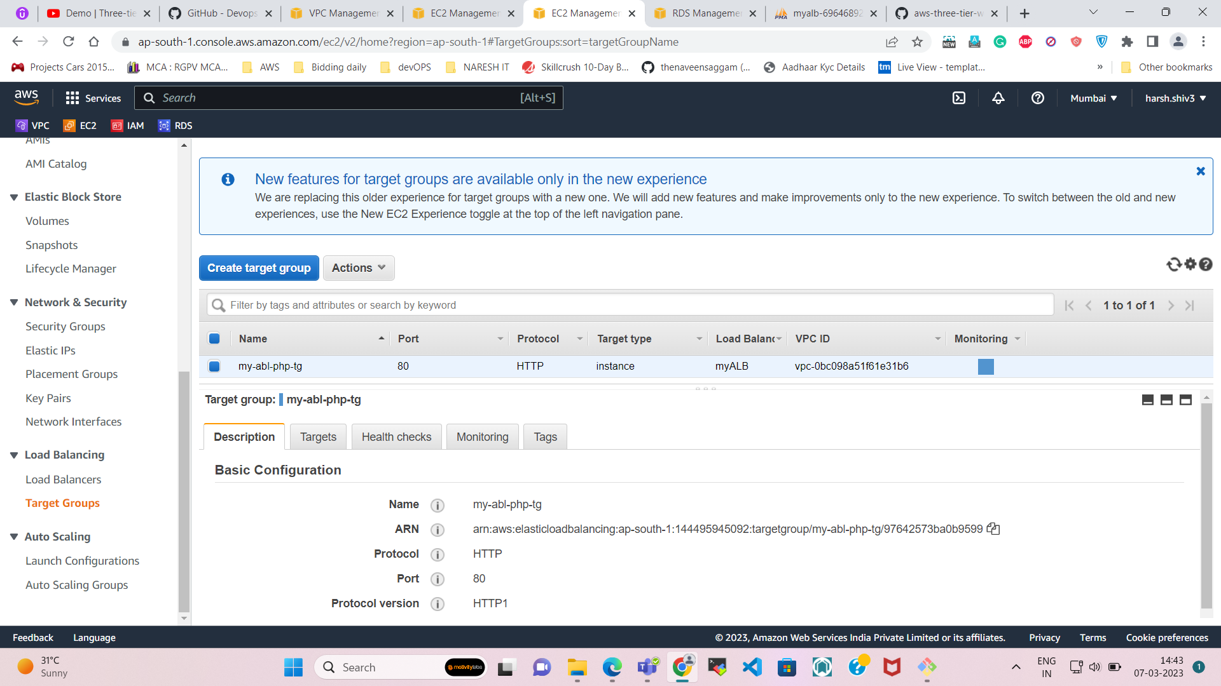

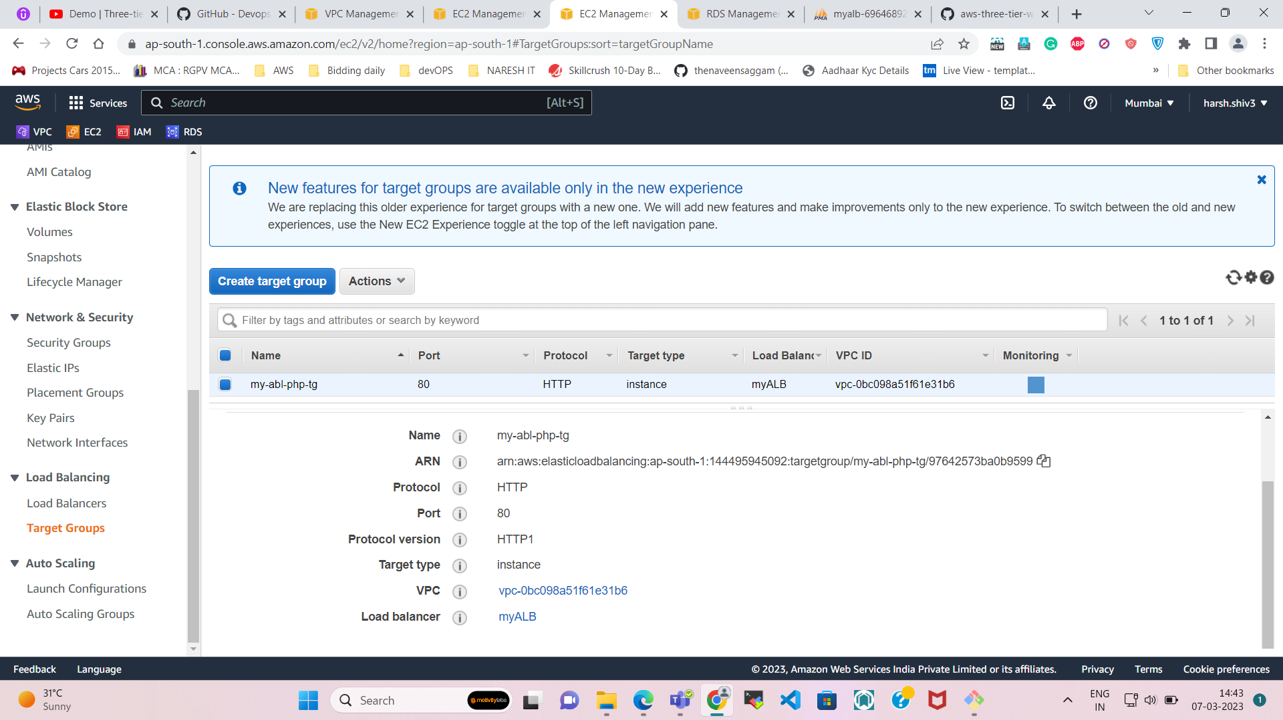

**You can see the registered targets in the below image.**

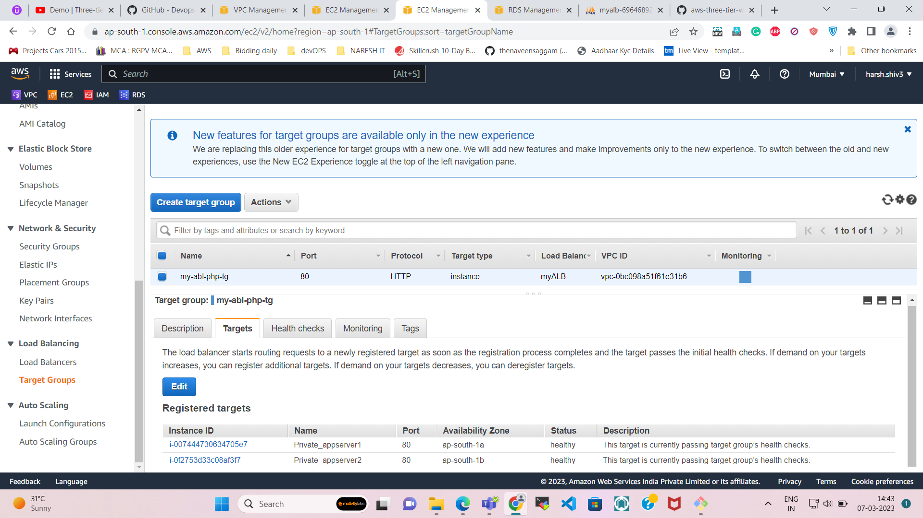

**Now we need to allow the LOAD BALANCER security group in the private app server security group.**

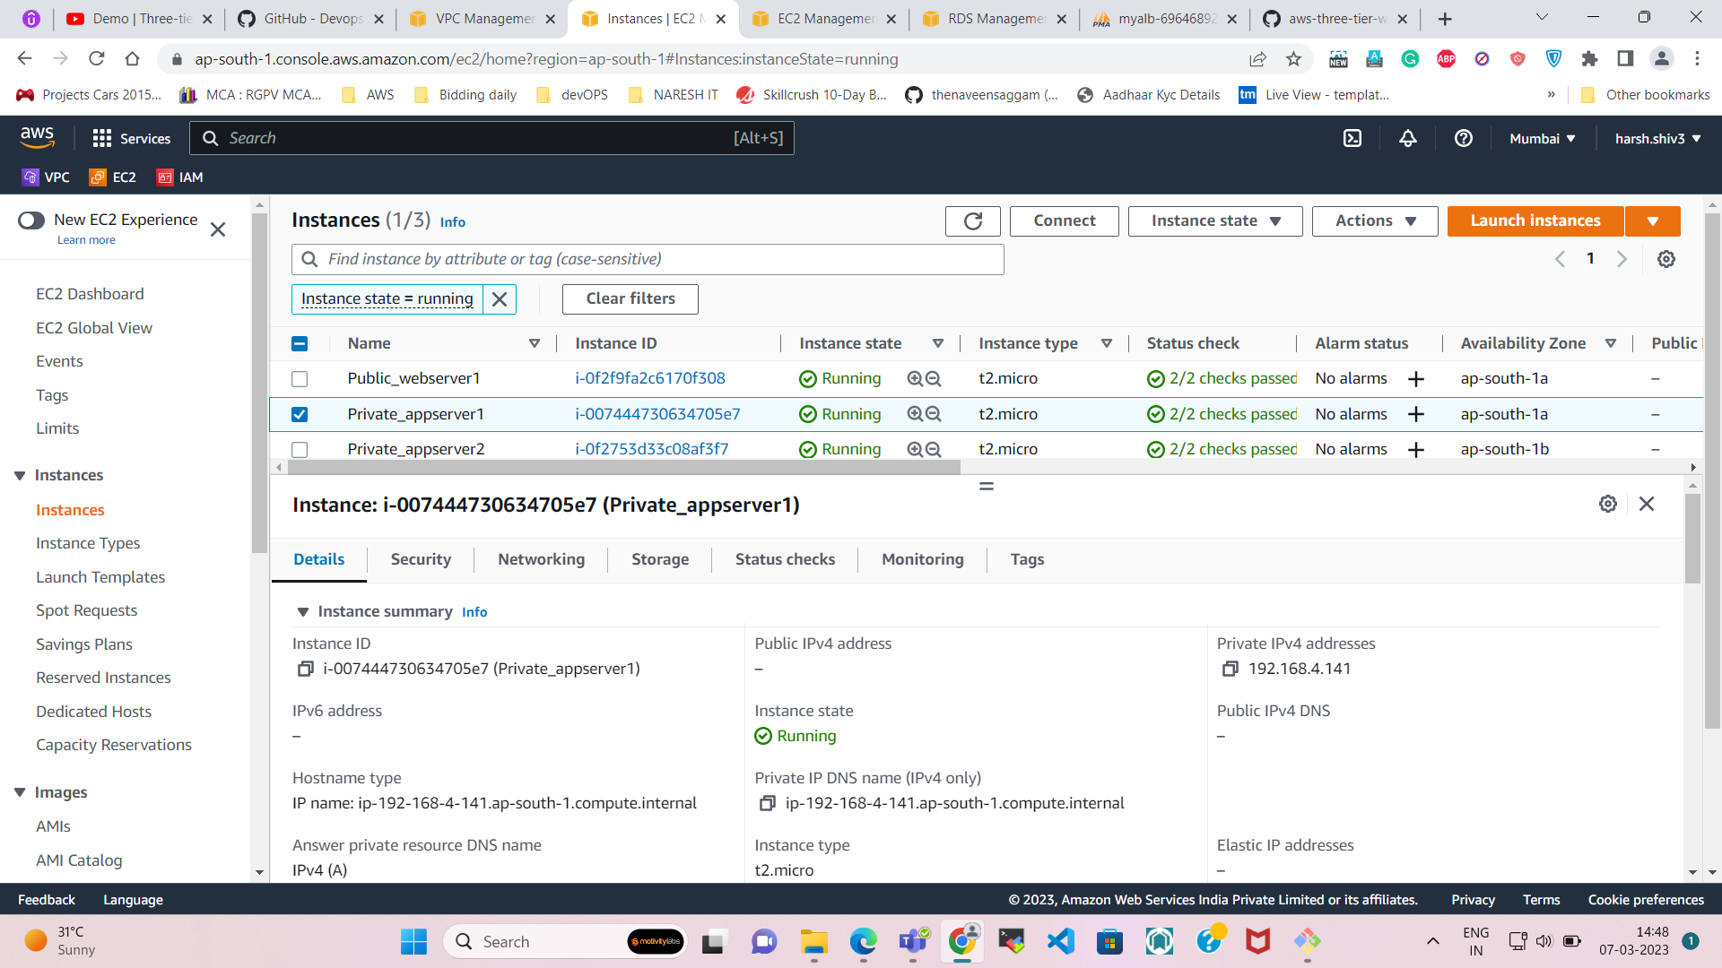

Edit inbound rule of private aapserver1

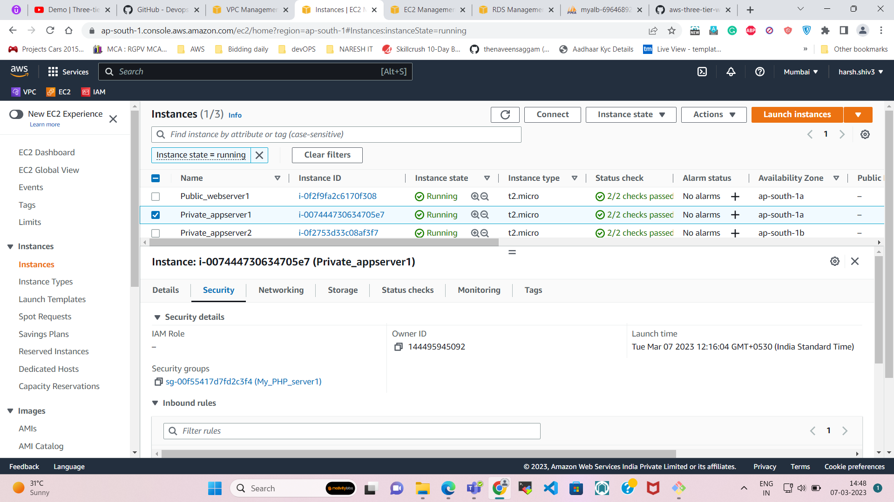

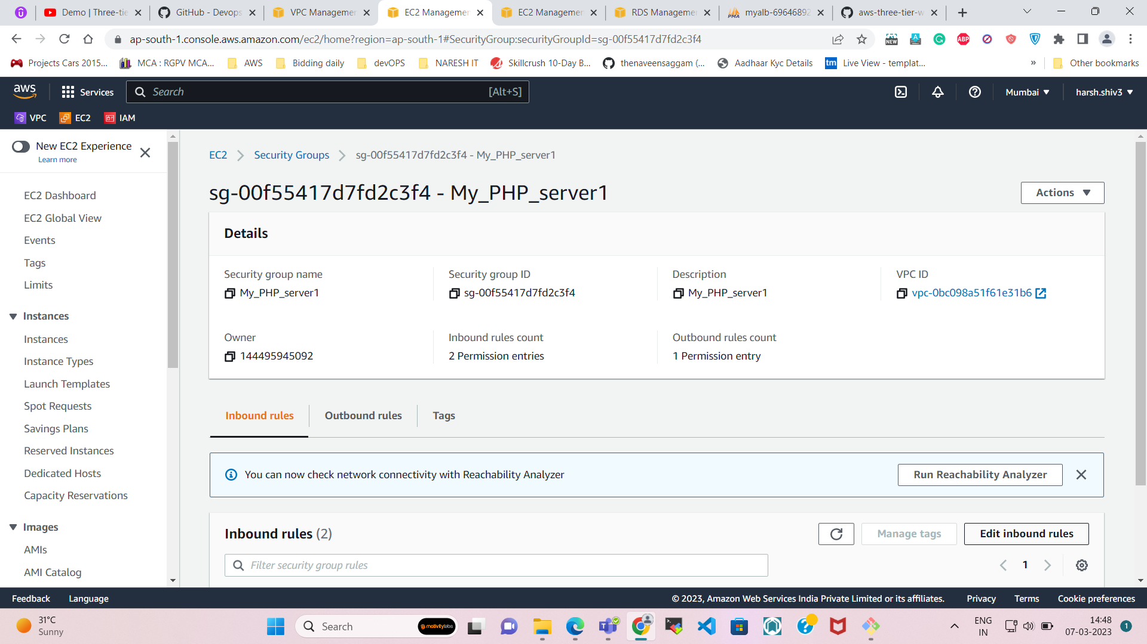

Select the security group of ALB.  
  
This will establish the connection between your ALB & instances.

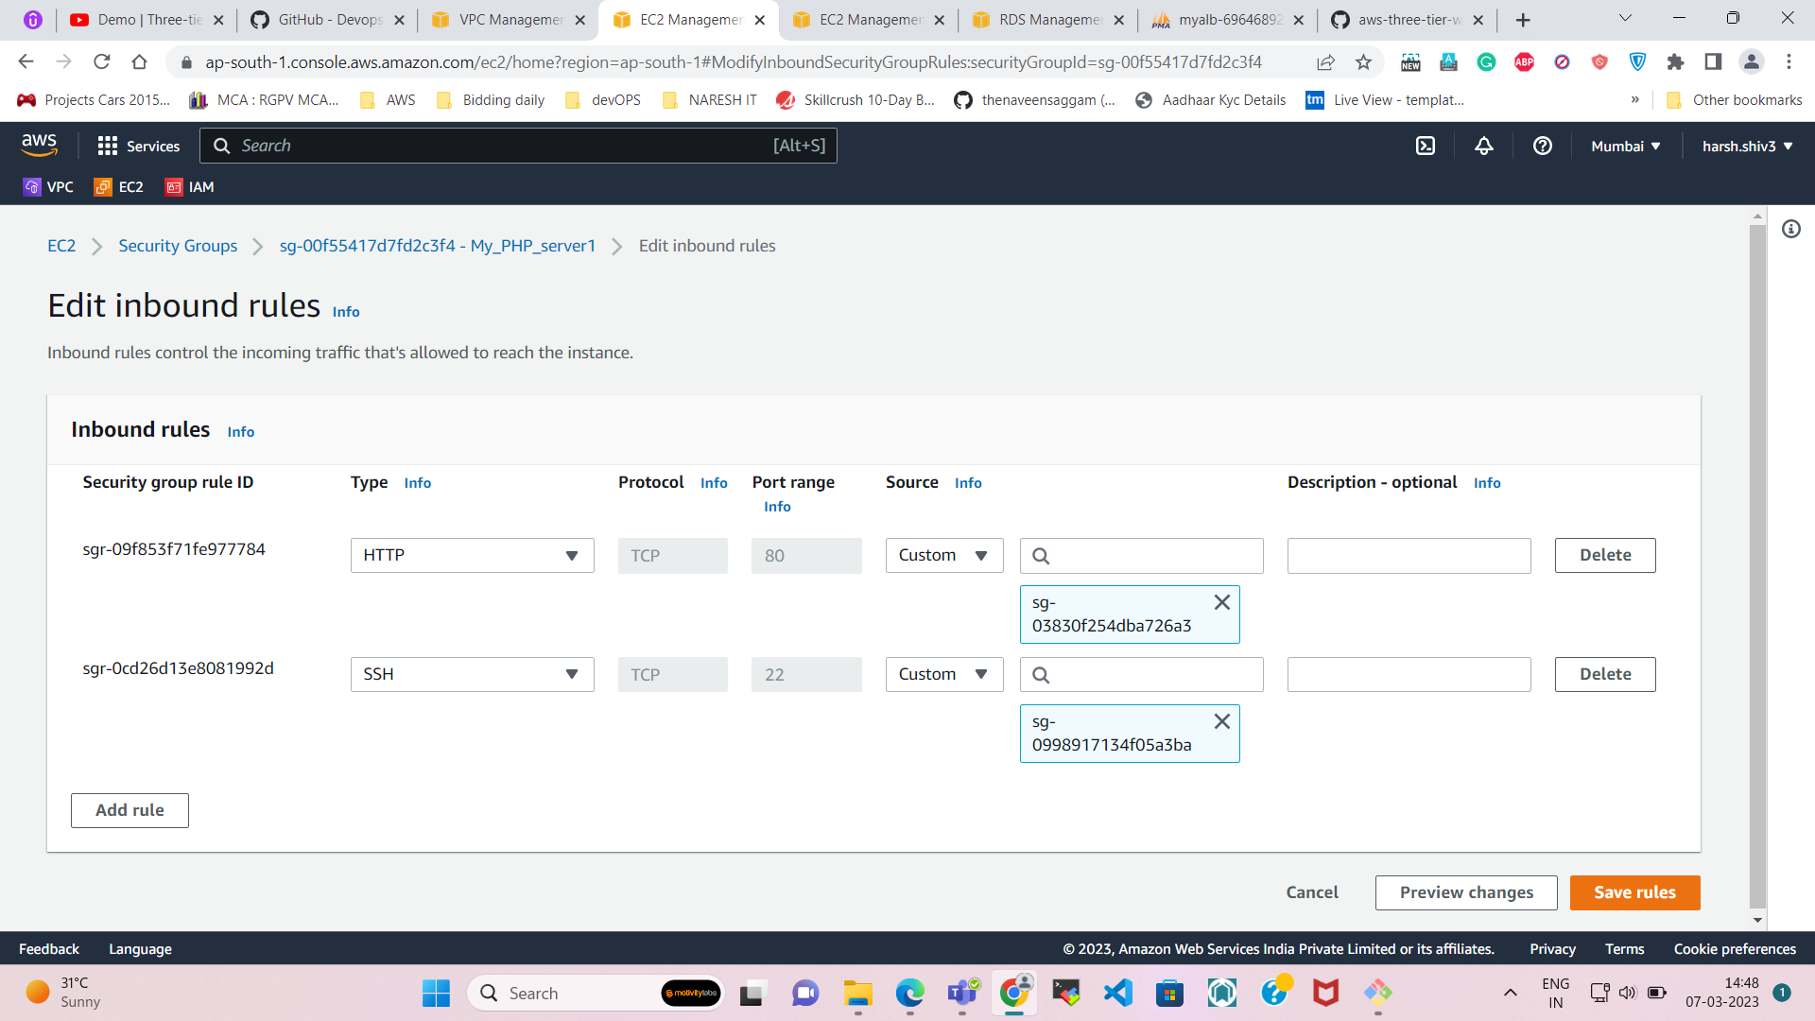

**Now copy the DNS Name in the LB and paste in the browser to check its working or not.**

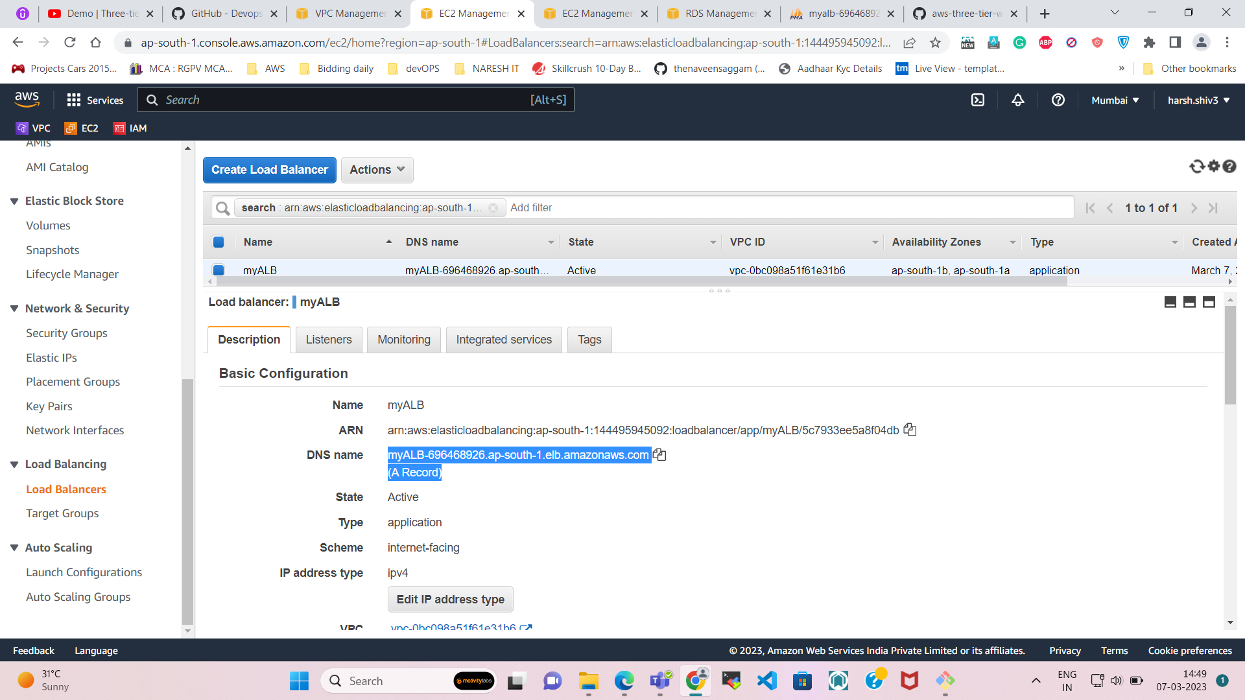

Now you can see that my ALB is working fine.

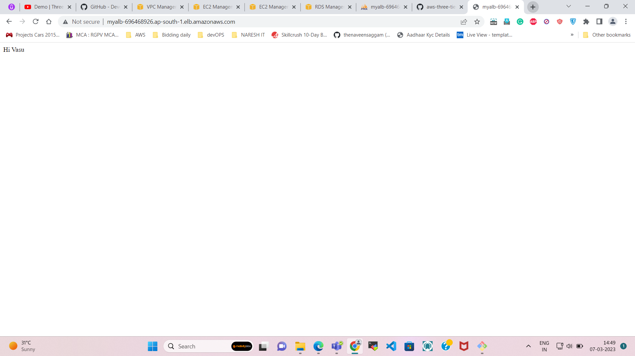

**Step-10**  
  
**Create RDS (Database) for the project.**

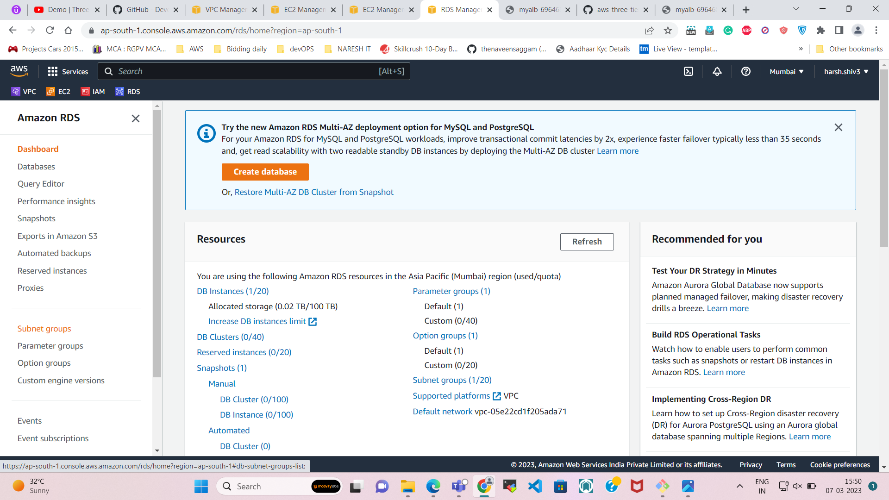

Before creating RDS we need to create a Subnet group for it.

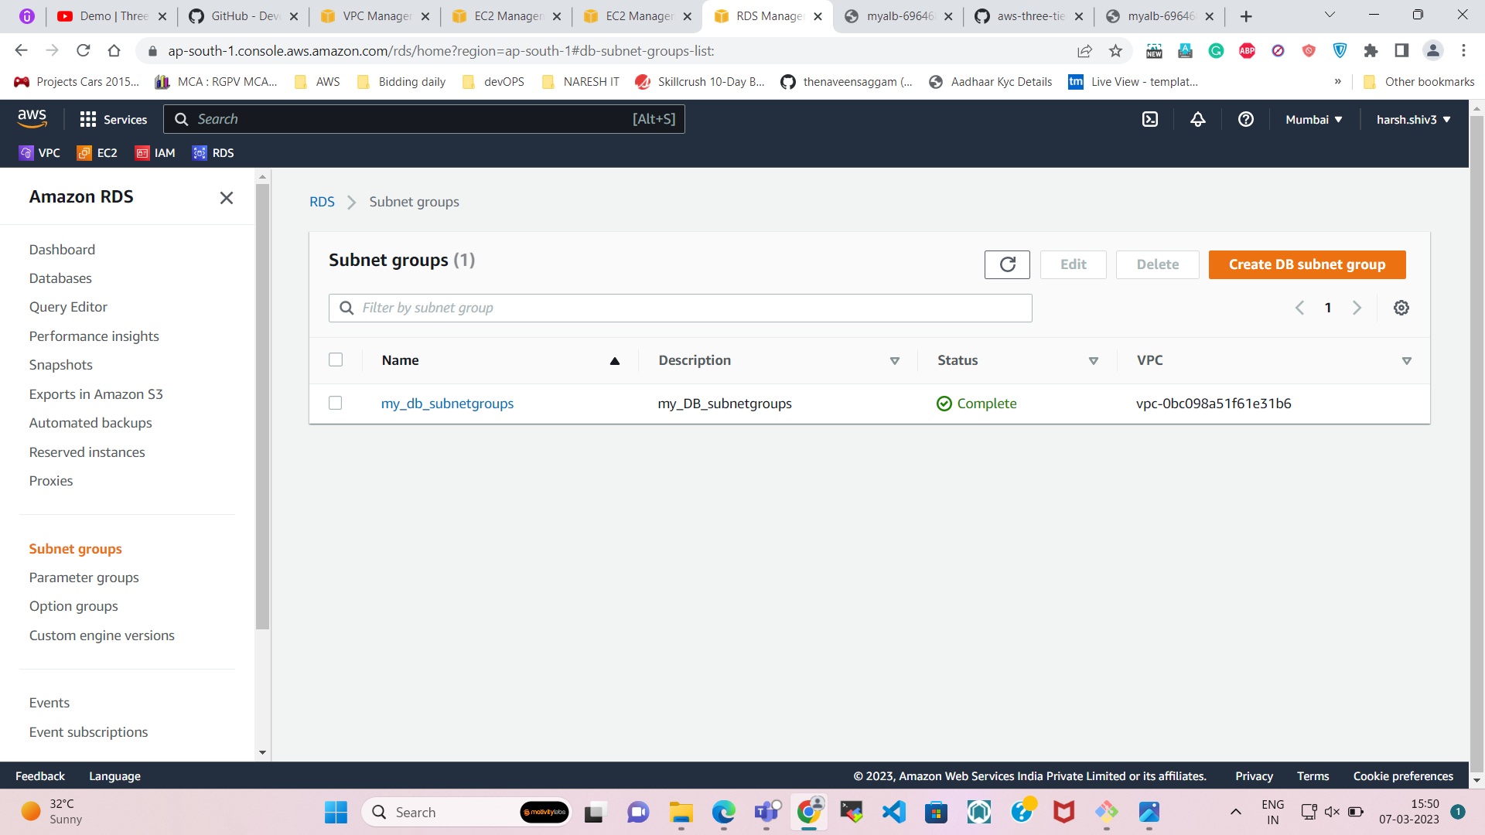

**\*\* Select the Subnets which we have created for the DB. (192.168.8.0/24 & 192.168.9.0/24)**

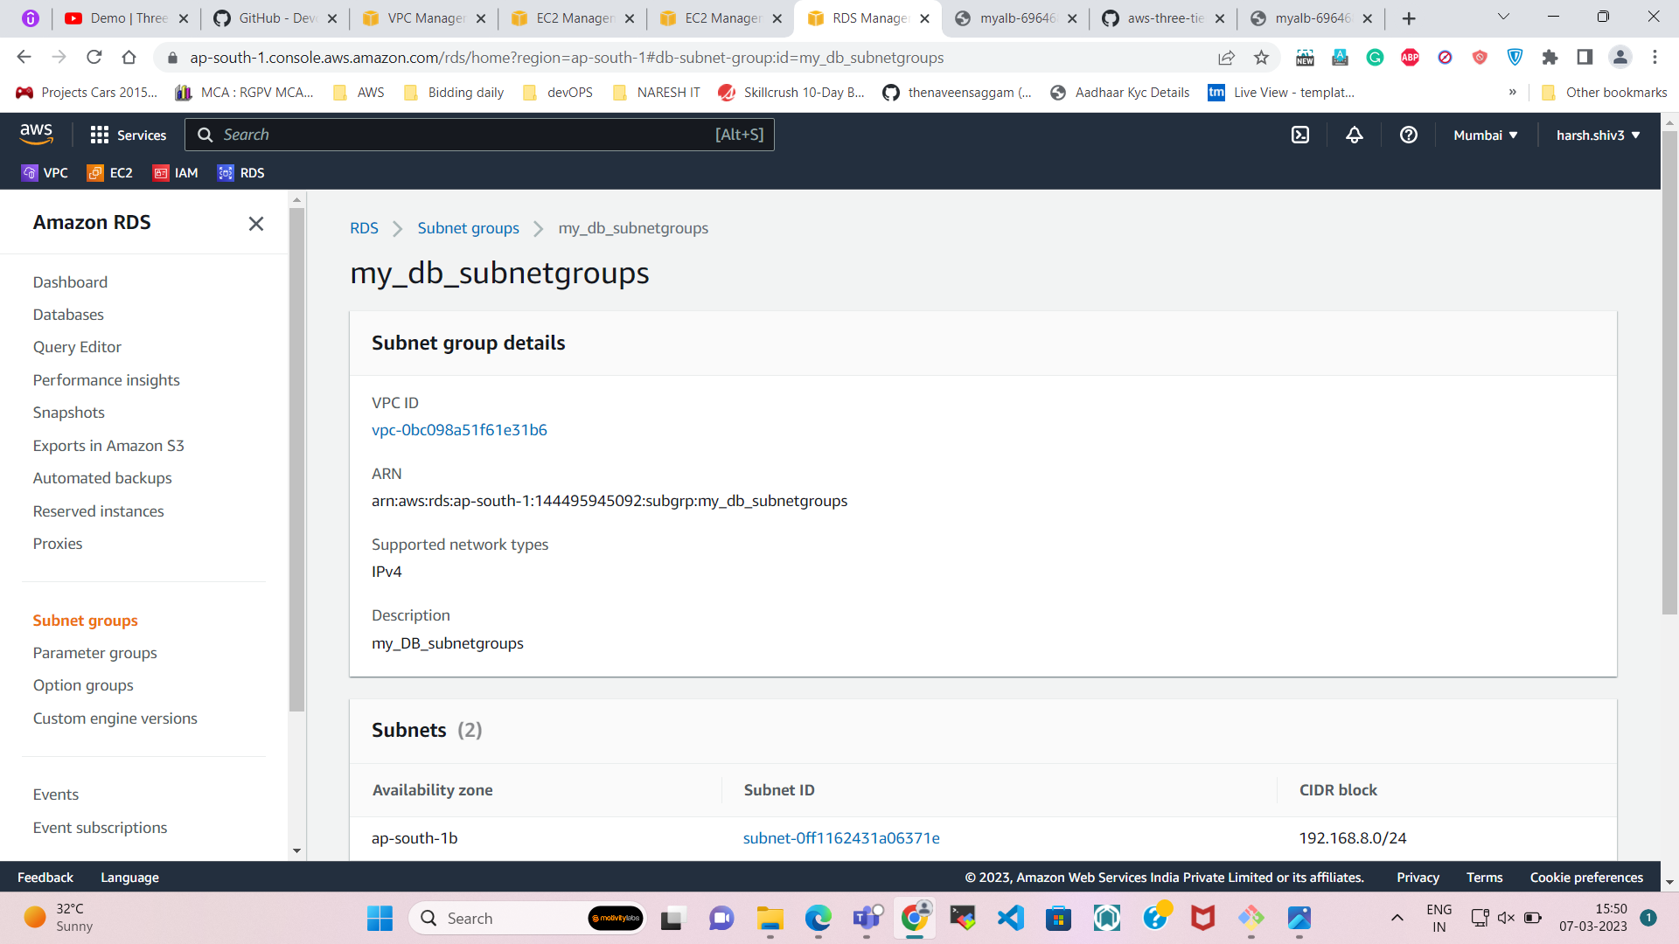

Create the **RDS DATABASE**

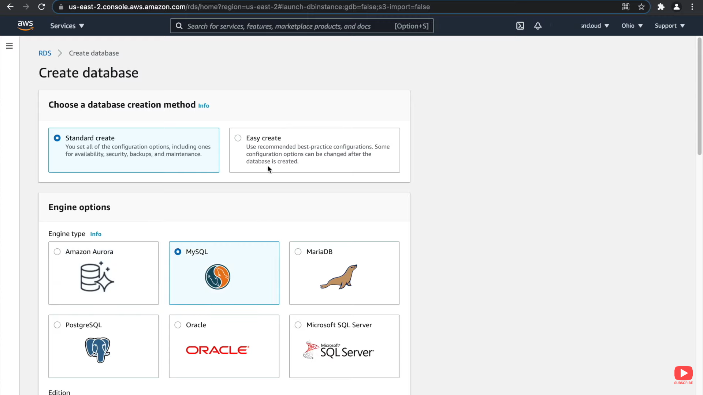

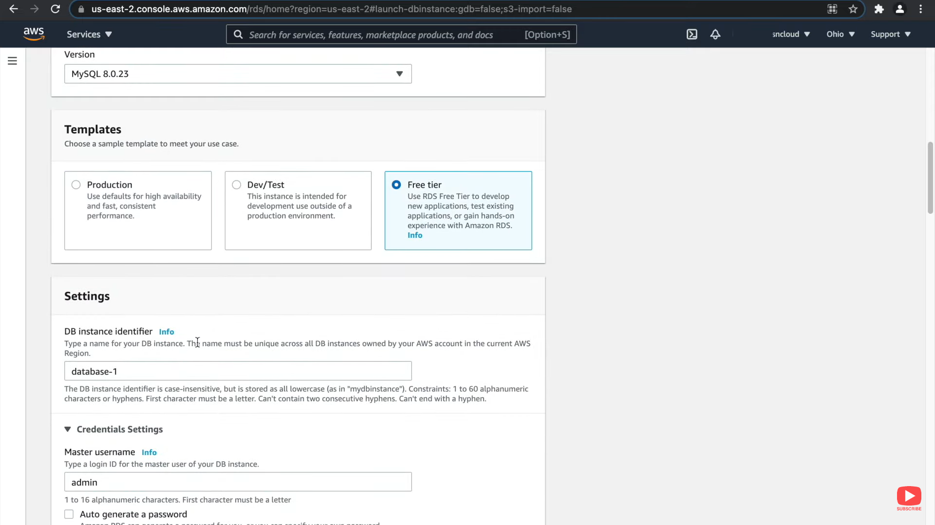

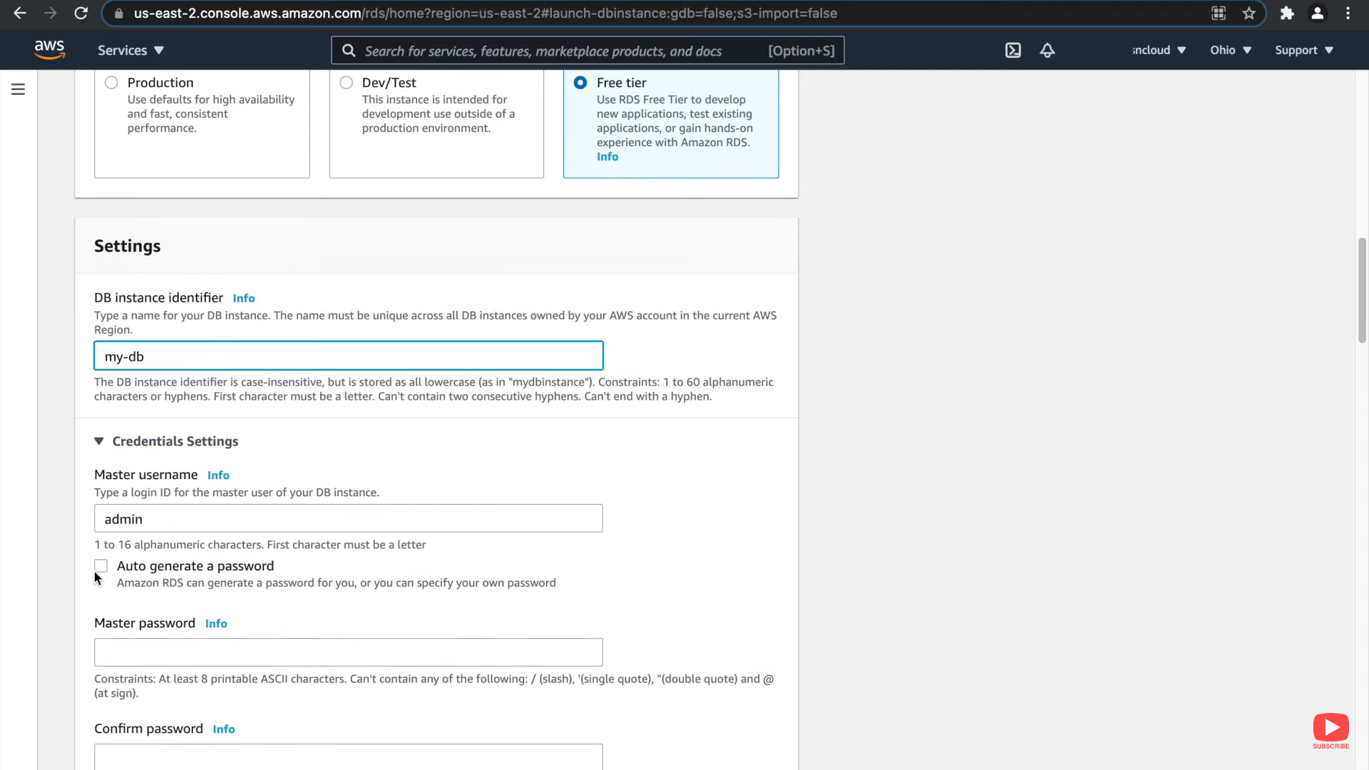

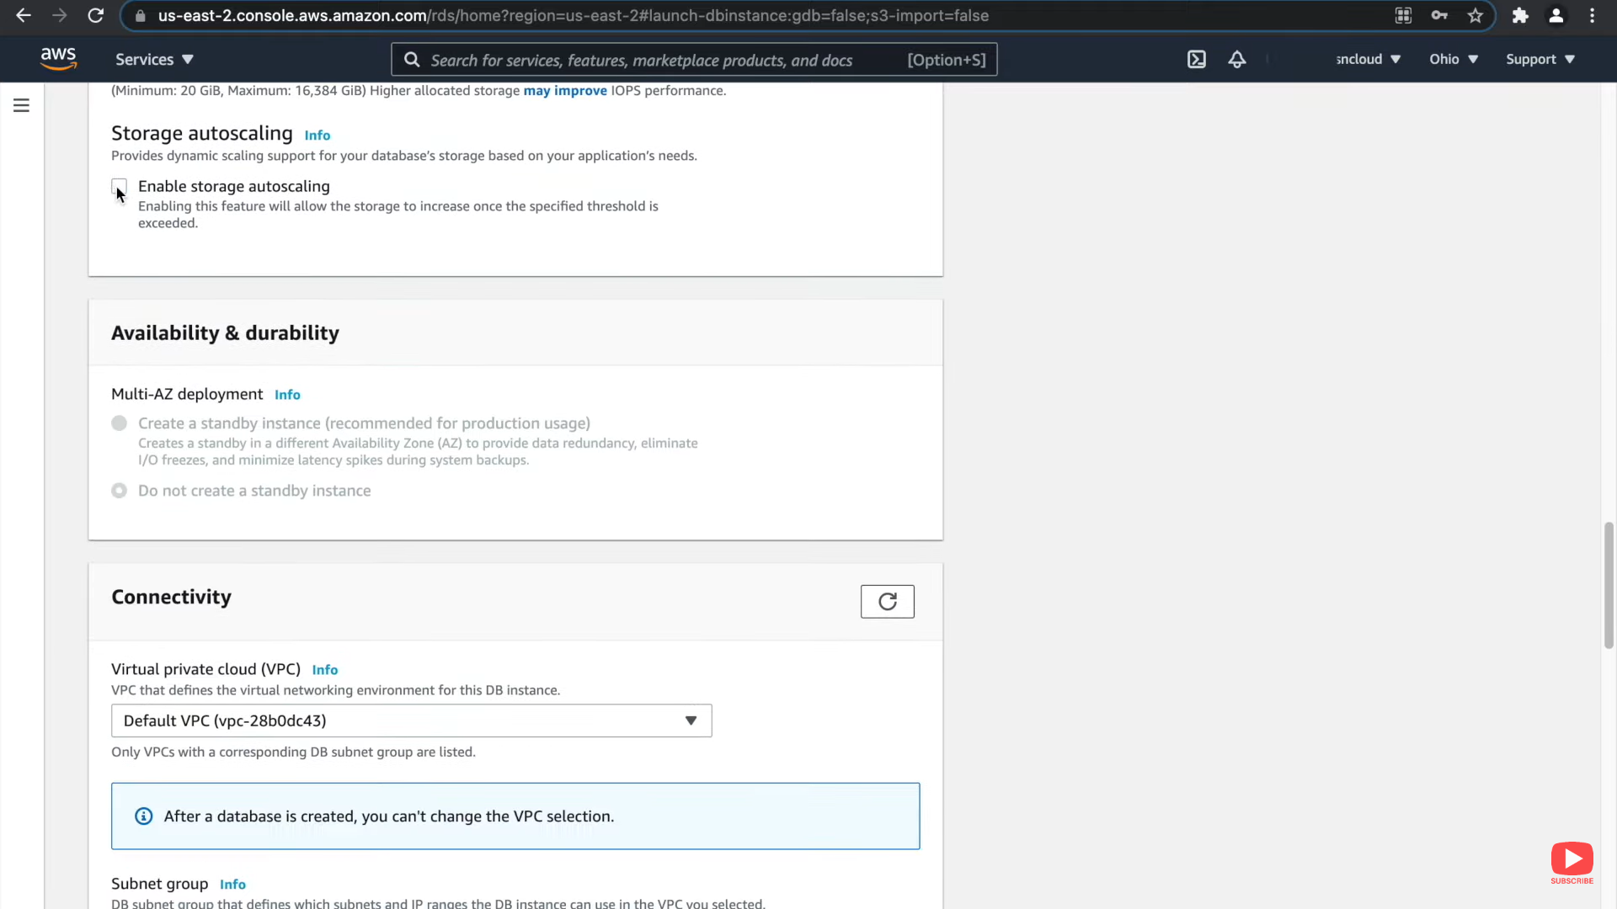

Select our own VPC.

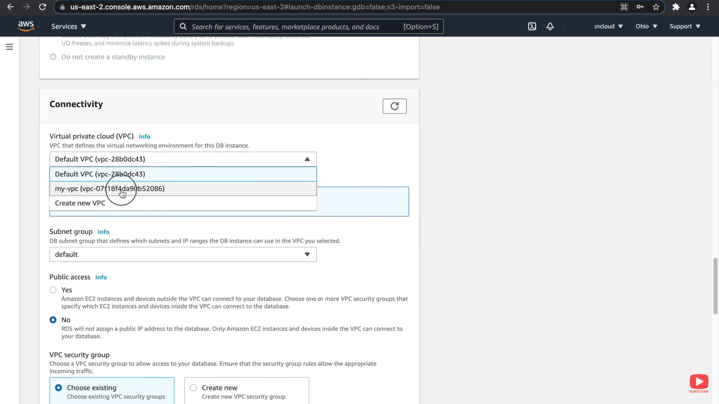

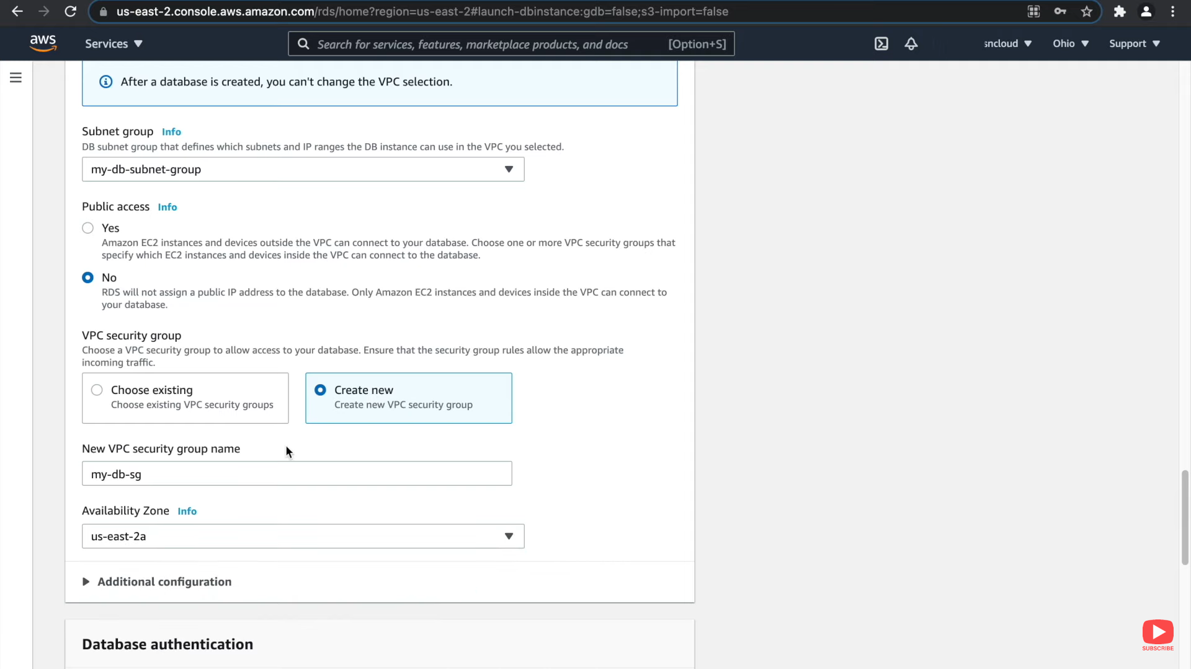

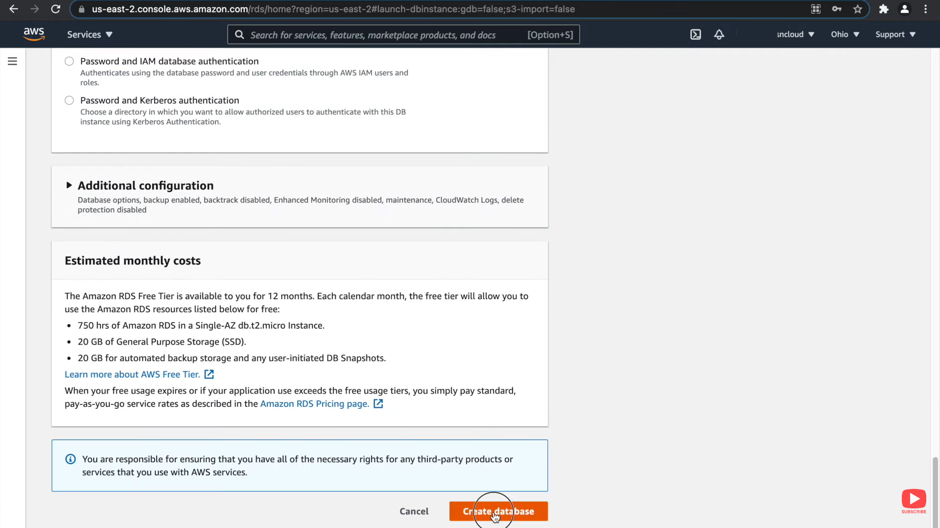

**Now Database is ready.**   
**Next step is to ENABLE the connectivity between your APP server & DB server.**

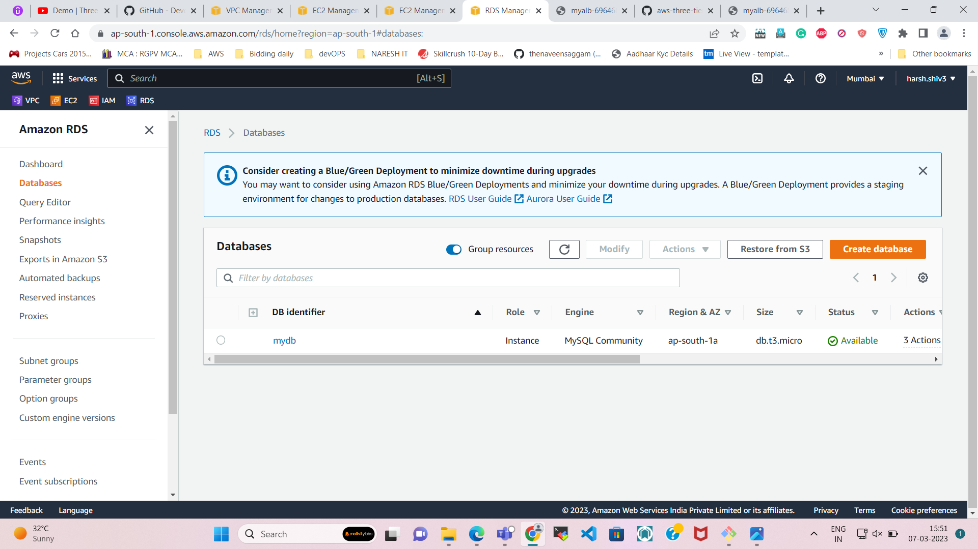

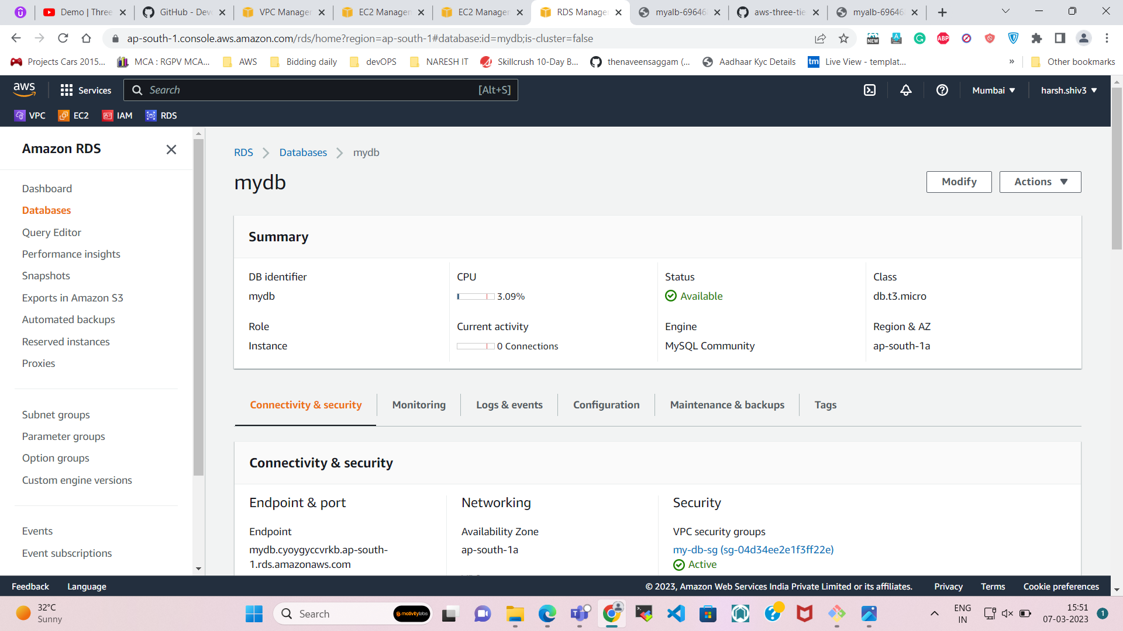

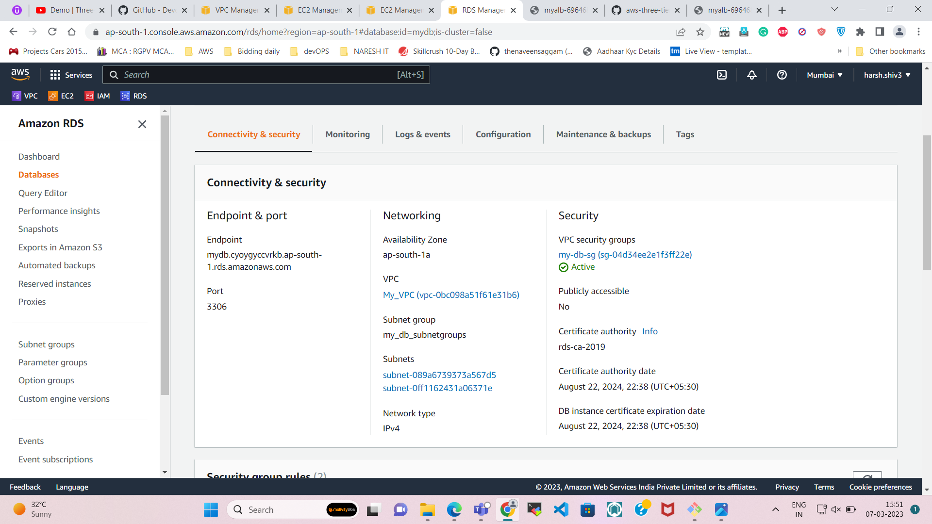

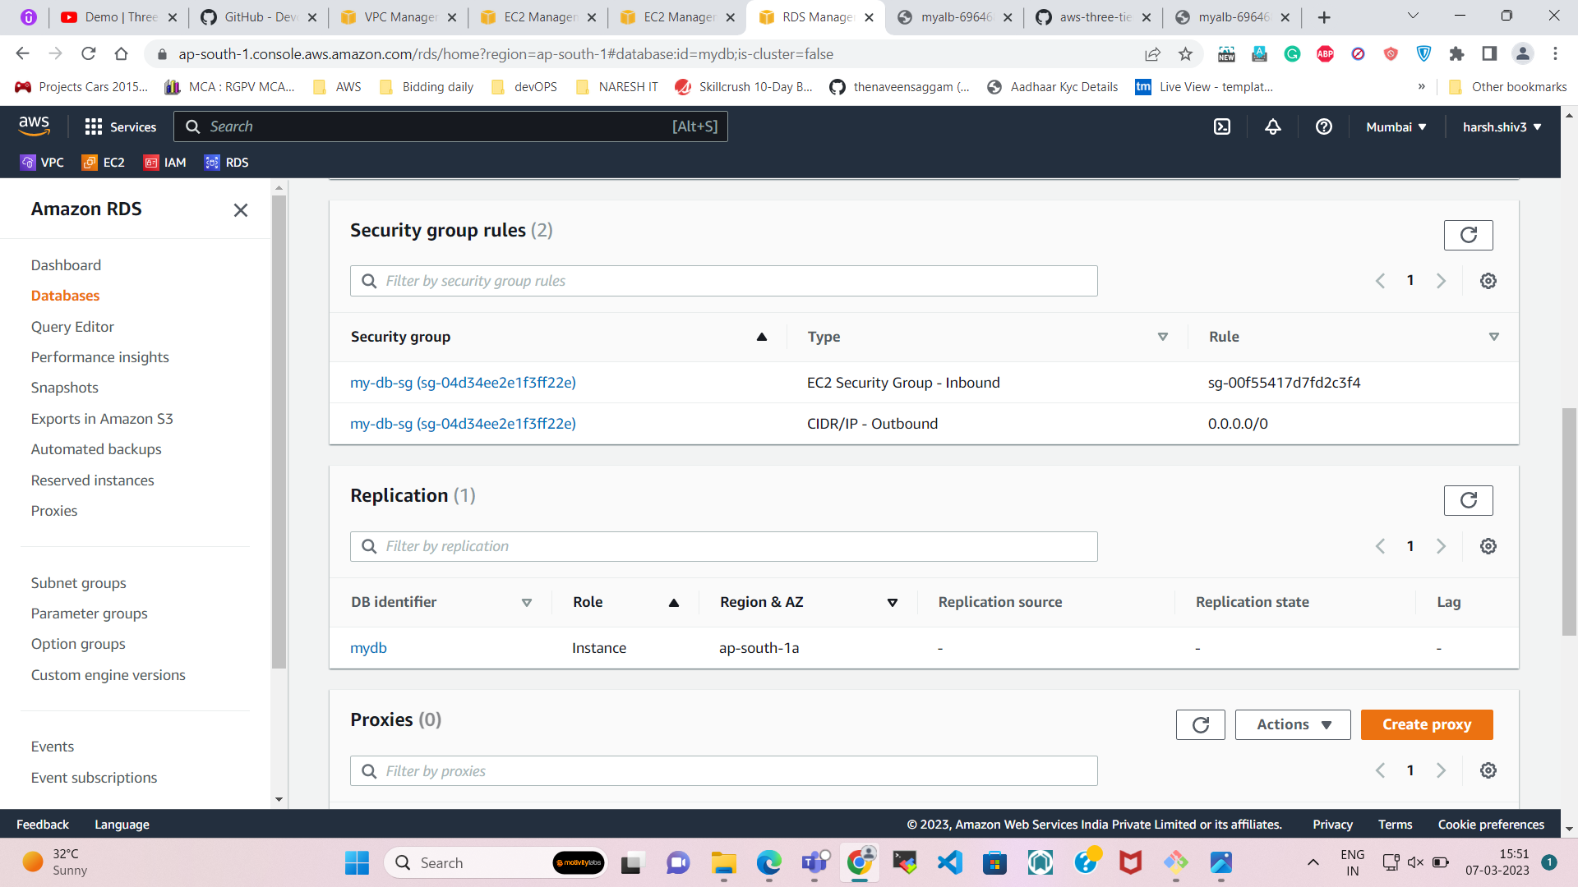

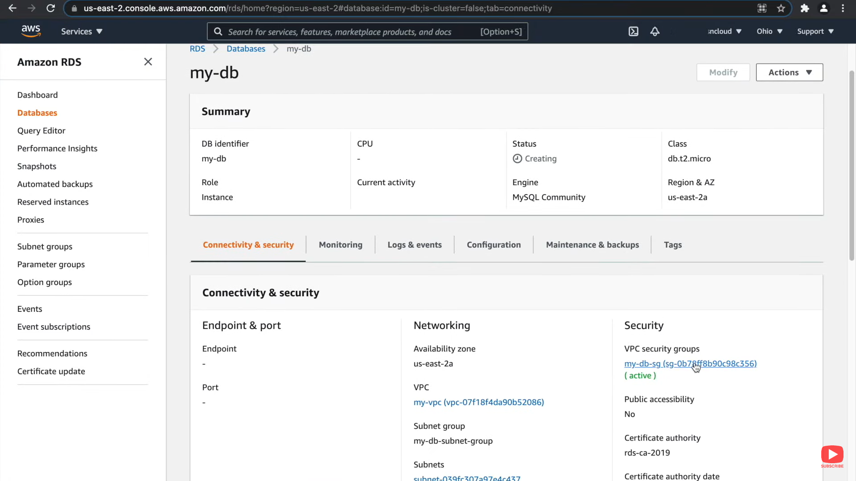

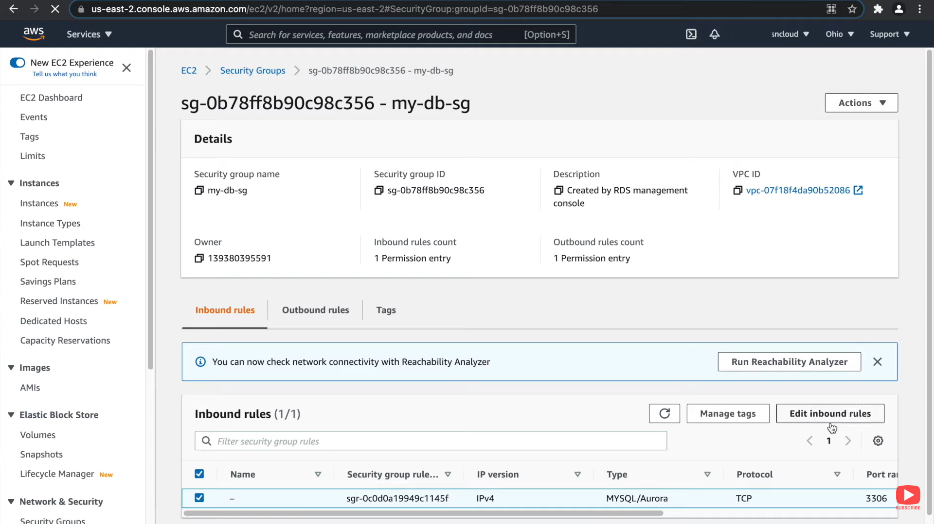

**So, we have to go the security of the DB and add 1 new rule for the PHP App Server.**

And we will delete the default rule.

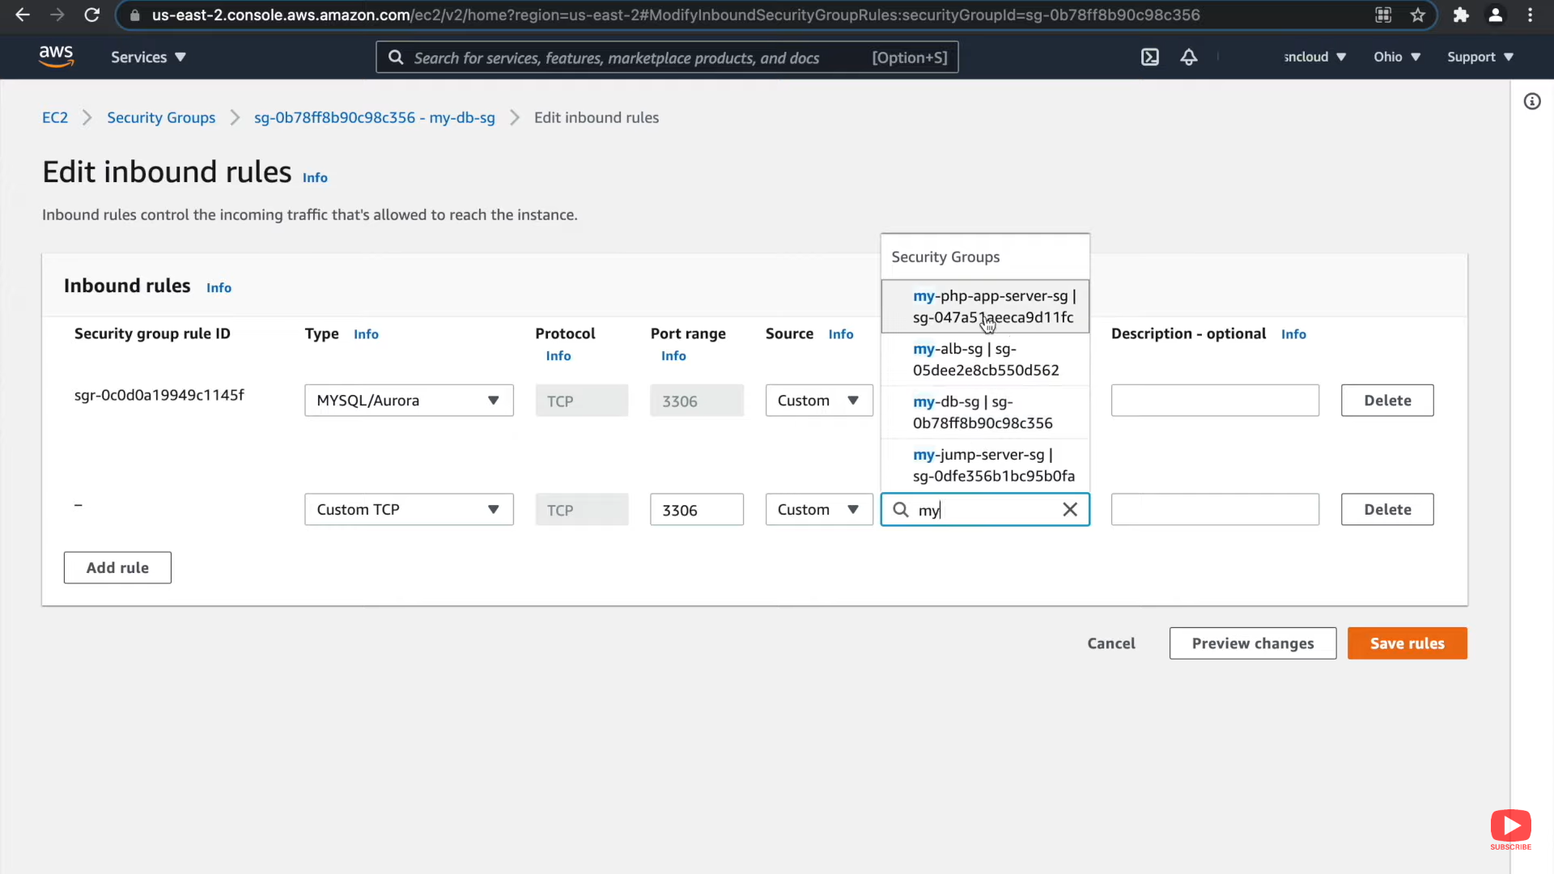

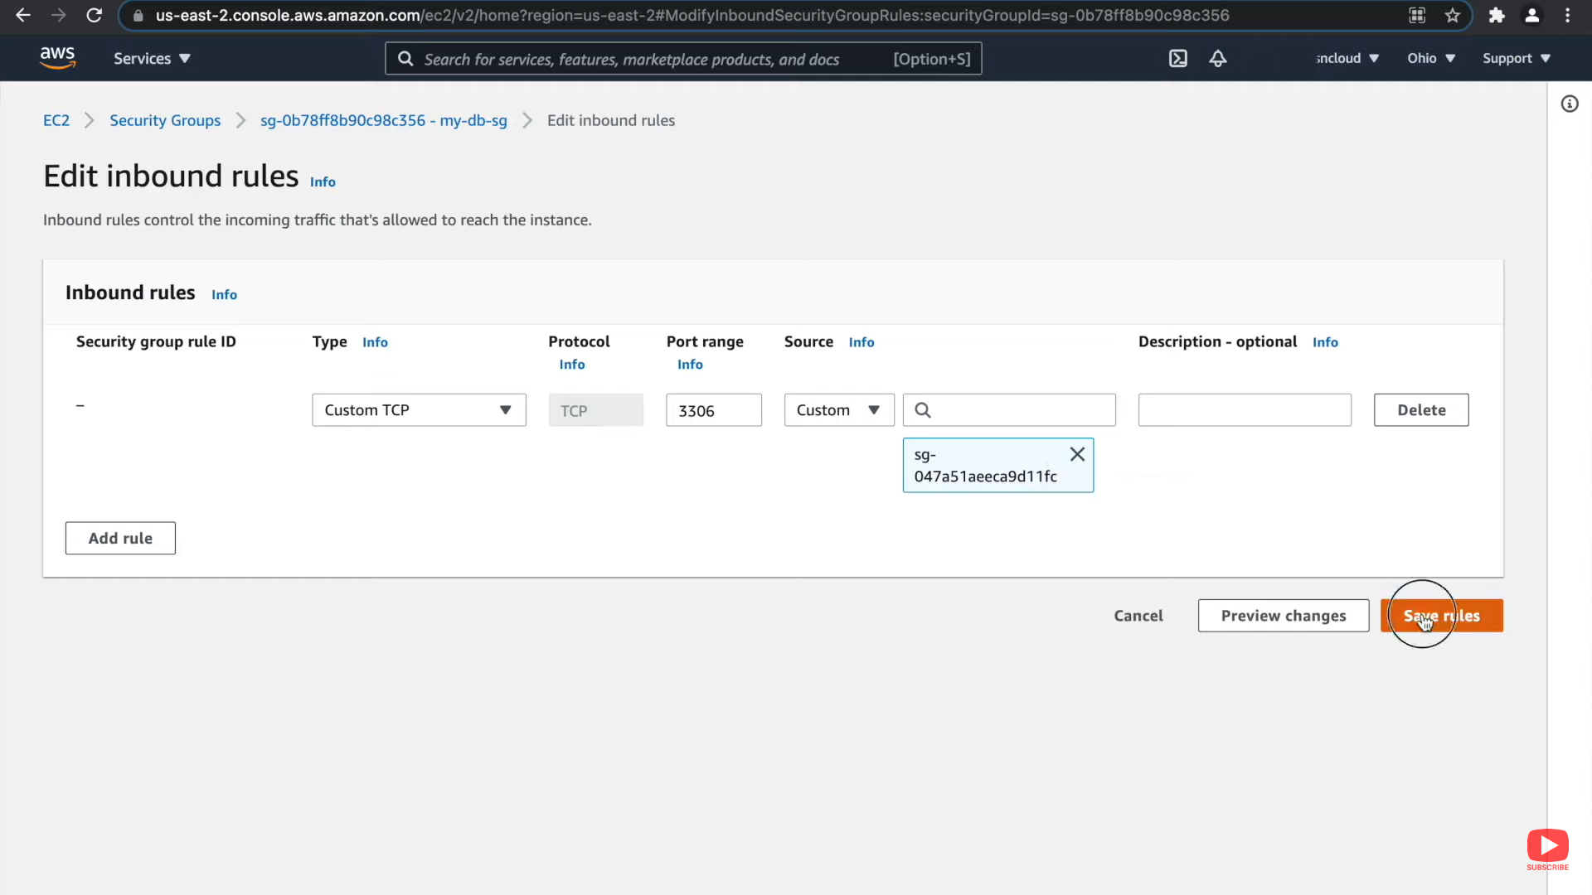

**Step-11**  
  
Now **Copy the ENDPOINT** & we will **navigate** to the **phpMyAdmin folder**.

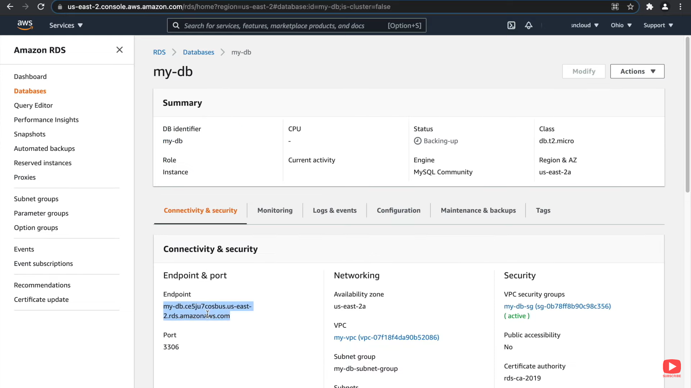

Open the phpMyAdmin folder.

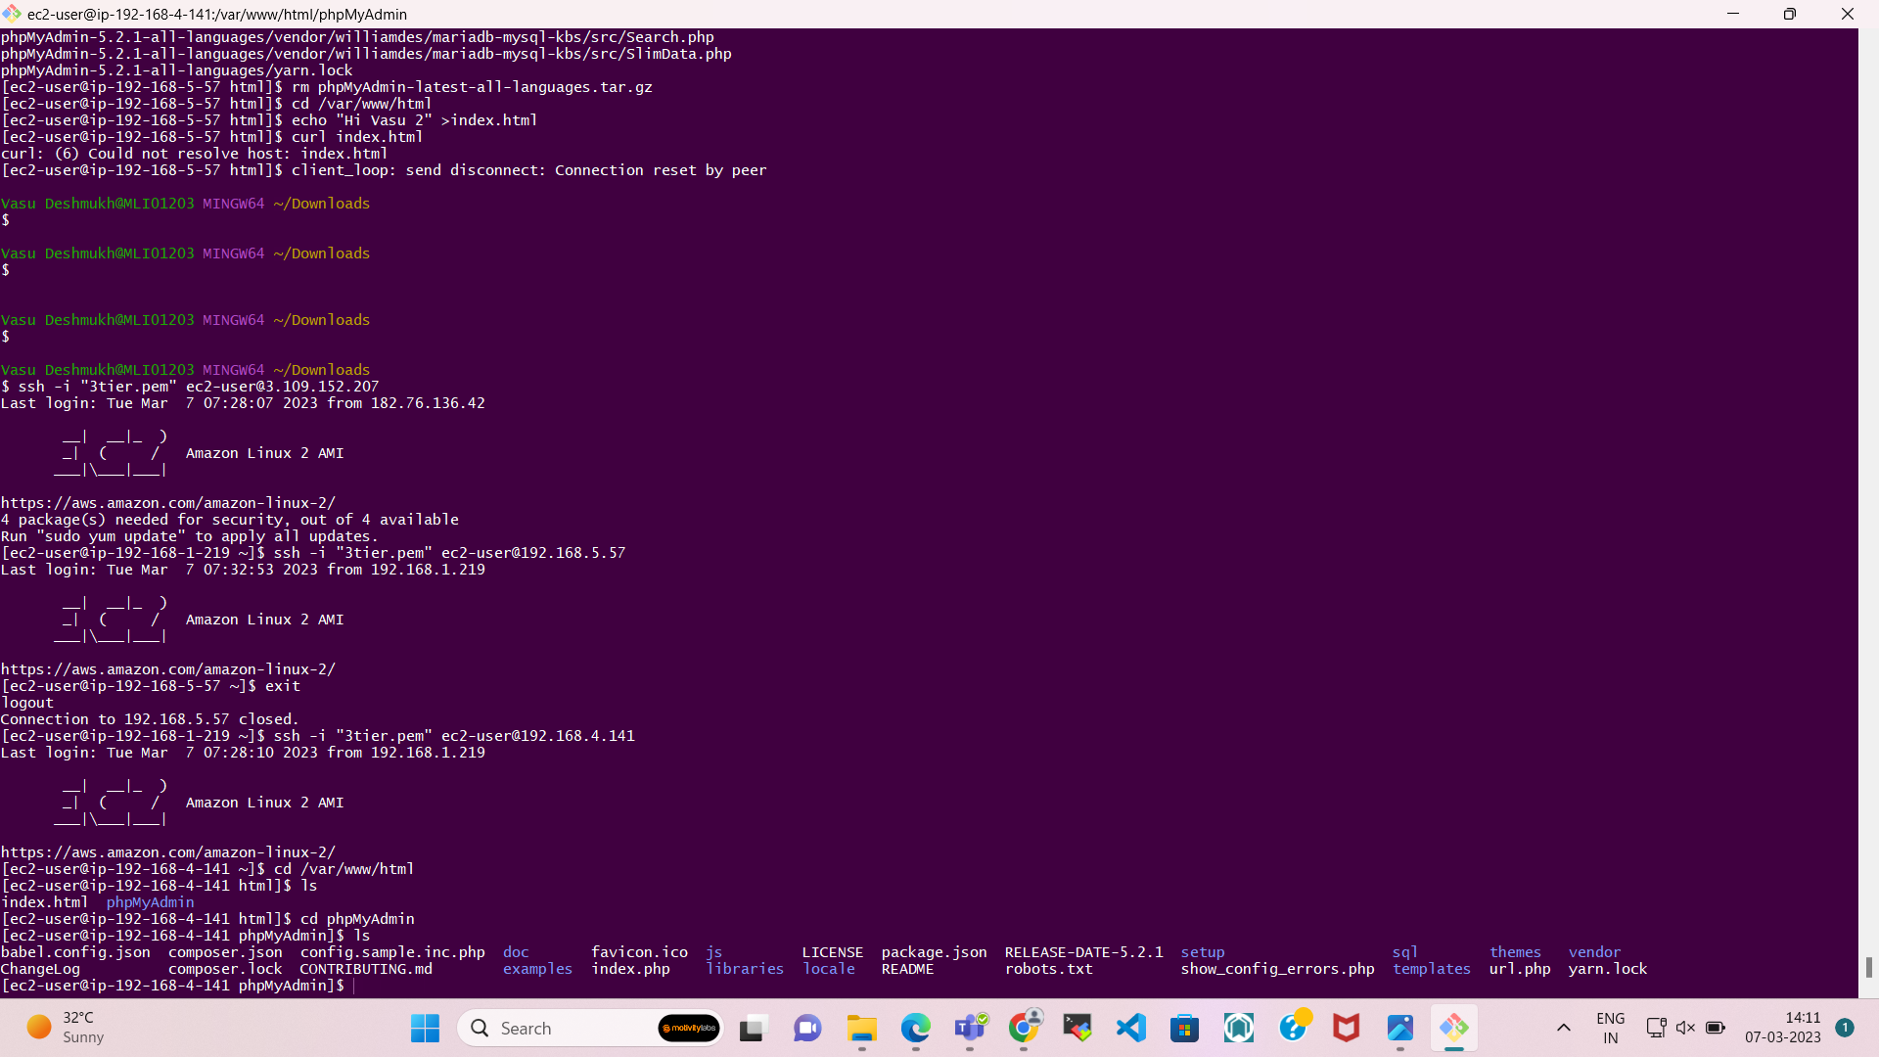

And Rename the file **config.map.inc.php** to **config.inc.phpconfig.inc.php**

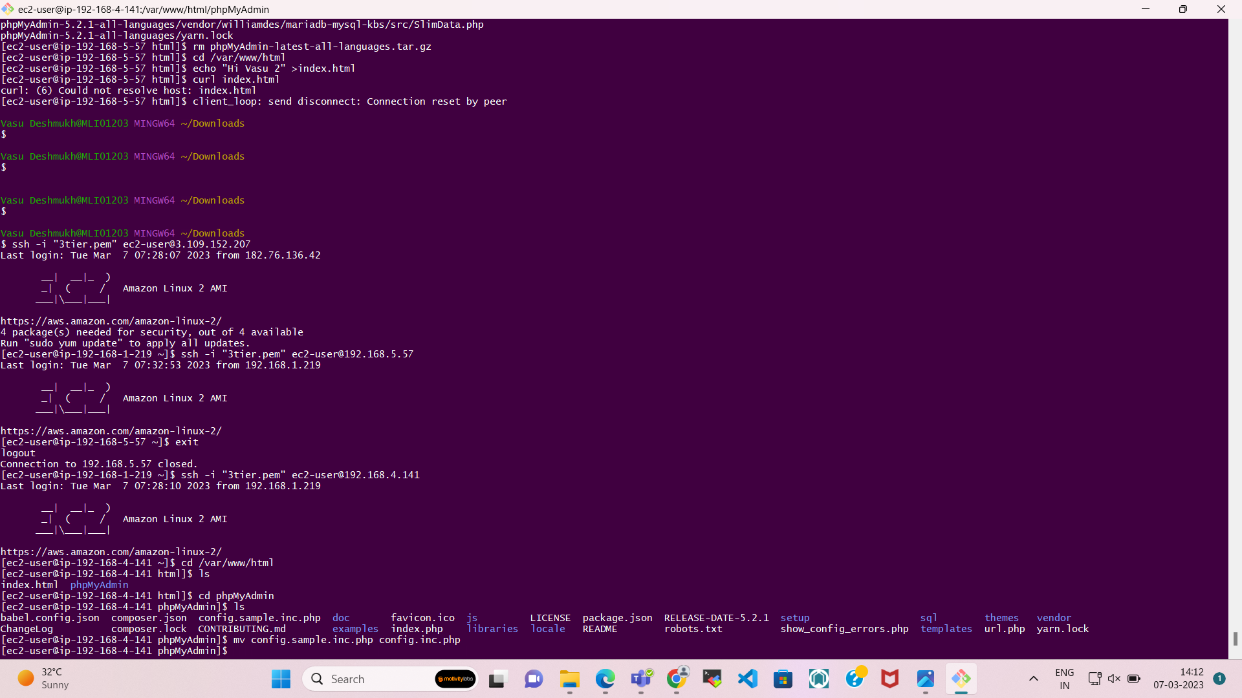

Now open that file & Search the host.  
Replace **“LOCALHOST”** with copied hostname of **“RDS**”.

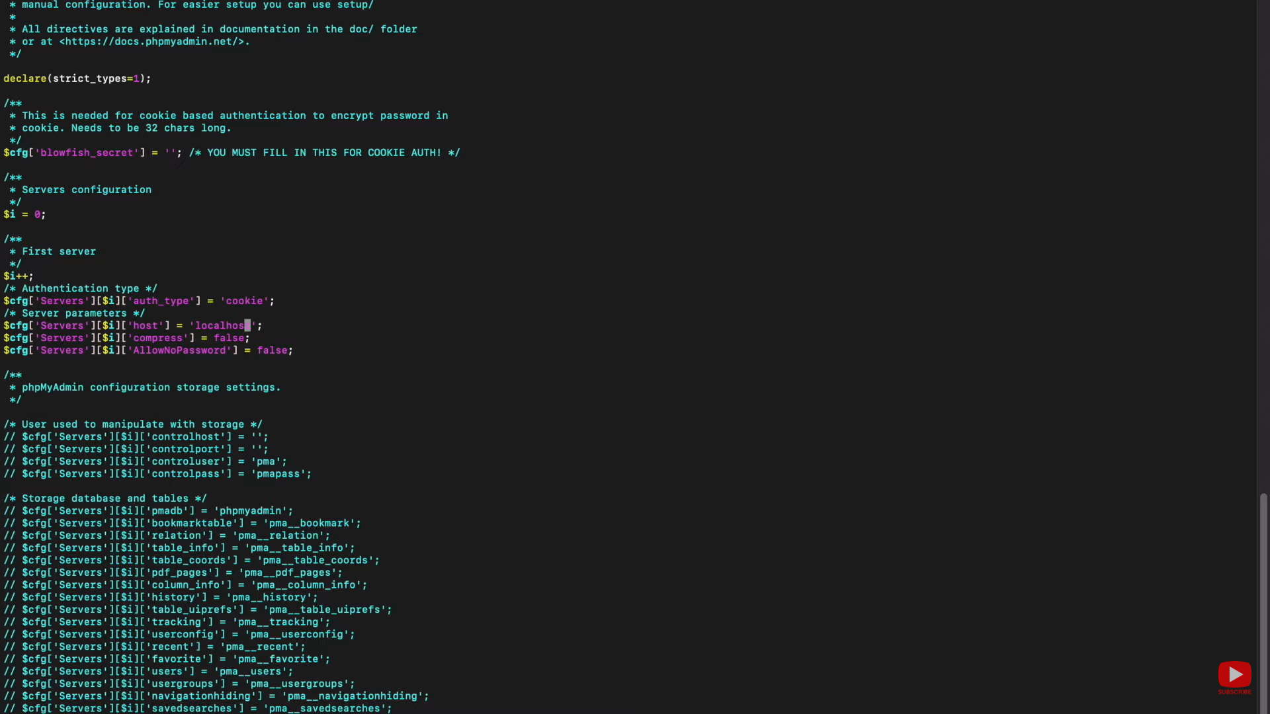

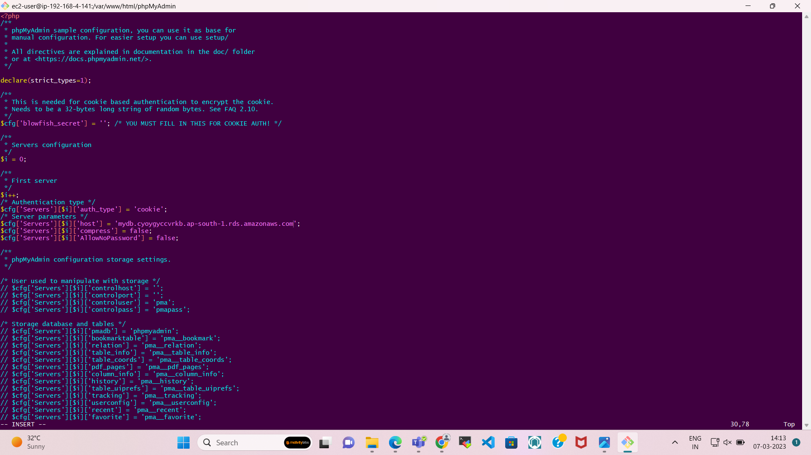

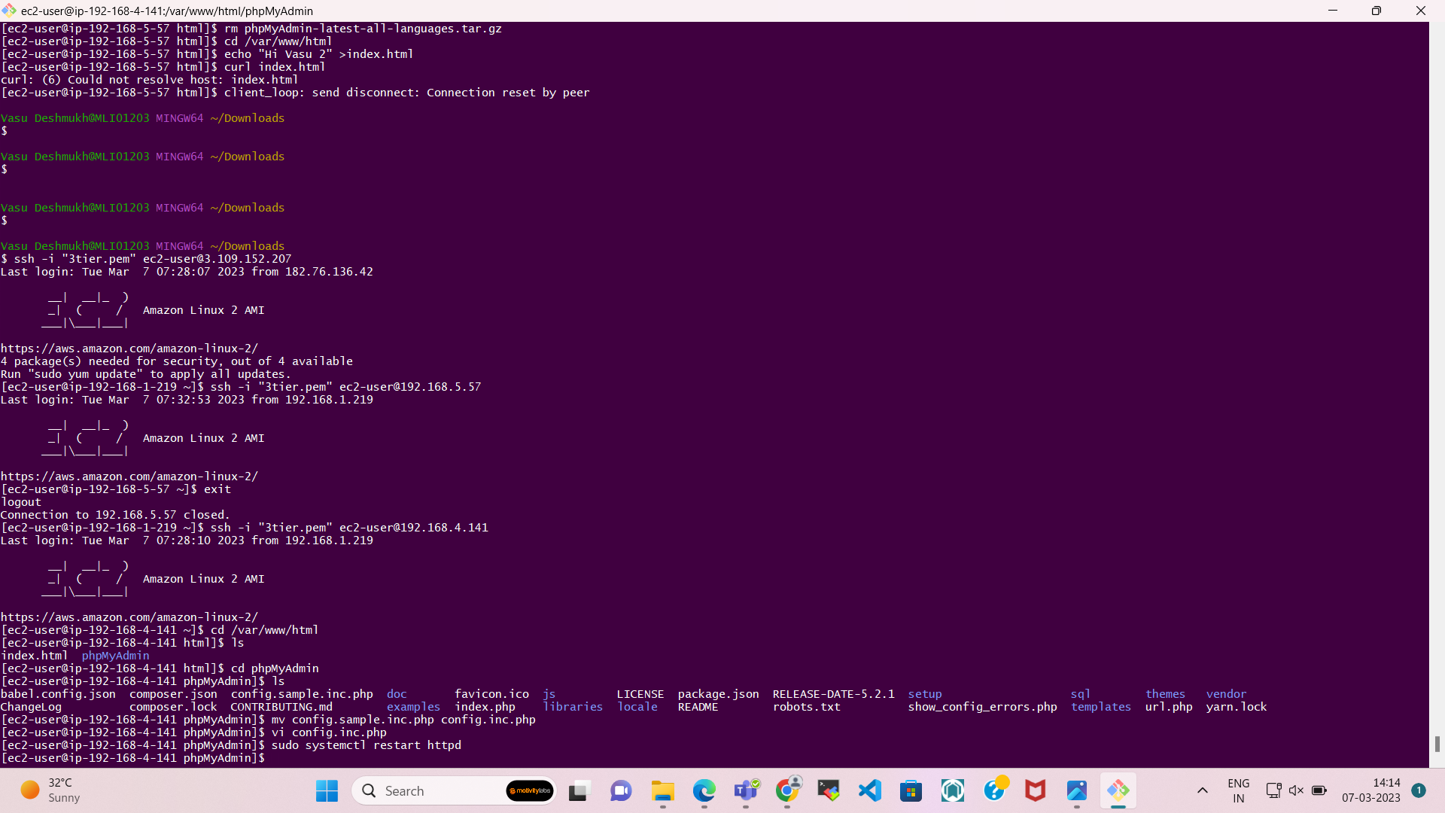

**Now save the file. & open the browser and at the end of search bar add /phpMyAdmin.**

